

**THE INFORMATION, COMMUNICATION AND TECHNOLOGY UNIVERSITY (ICTU), Yaoundé, Cameroon.**

**DESIGN AND IMPLEMENTATION OF A TUTOR BOOKING APPLICATION TO STREAMLINE LEARNING PROCESSES (TutorFlux)**

**PROJECT REPORT**

A dissertation submitted in partial fulfilment of the requirement for the award of a **BACHELOR OF SCIENCE IN SOFTWARE ENGINEERING (BSc)**

By

**YENNYUYGHA PASCAL**

**ICTU20212245**

**Faculty of Information and Communication Technology**

**MAJOR IN SOFTWARE ENGINEERING**

Supervised by:

**Eng. TANWI NKIAMBOH**

**Academic year 2023-2024**

# DECLARATION

I declare that the work entitled “**DESIGN AND IMPLEMENTATION OF A TUTOR BOOKING APPLICATION TO STREAMLINE LEARNING PROCESSES (TutorFlux)**” is my original work, conceived and presented in partial fulfilment of the requirement for the award of the degree of a Bachelor of Science in Software Engineering at the Information, Communication, and Technology (ICT) University. This work has not been submitted for any degree or examination in any other university, and all the sources I have used or quoted have been indicated and acknowledged as complete references.

Name: **YENNYUYGHA PASCAL**

Registration Number: **ICTU20212245**

Signature: __________________________

Date: __________________________

# CERTIFICATION

This project titled “**DESIGN AND IMPLEMENTATION OF A TUTOR BOOKING APPLICATION TO STREAMLINE LEARNING PROCESSES (TutorFlux)**” is at this moment approved as a credible study in Software Engineering carried out by YENNYUYGHA PASCAL (ICTU20212245) a student at the ICT University in a satisfactory manner to warrant its acceptance as a prerequisite to the degree of Bachelor in Science in Software Engineering for which it has been submitted.

Eng. [Supervisors name]

Lecturer, the ICT University, Cameroon

Signature: __________________________

Date: __________________________

# DEDICATION

This project is dedicated to my parents, whose sacrifices and belief in my abilities have driven me to achieve my goals. To my professors, whose guidance and wisdom have shaped my academic journey, and to every learner and educator, who believes in the transformative power of knowledge and education.

# ACKNOWLEDGEMENT

I would like to express my sincere gratitude to:

God almighty for the strength, guidance, protection, and wisdom pondered upon me to carry on this task from start to completion.

Eng. Tanwi Nkiamboh my Supervisor, and Dr Abdallah Ziraba of the ICT department of the Information, Communication, and Technology University for their endless and their diligent assistance via recommendations, comments, and adjustments which helped me remain focus and determined in carrying out this work.

My Parents, and Siblings for their support during this academic journey.

My friends who helped make this endeavour a success.

# FACULTY APPROVAL

This project titled **“DESIGN AND IMPLEMENTATION OF A TUTOR BOOKING APPLICATION TO STREAMLINE LEARNING PROCESSES (TutorFlux)”**,

Is at this moment approved as a credible study in Software Engineering carried out by **YENNYUYGHA PASCAL (ICTU20212245)** a student at the ICT University in a satisfactory manner to warrant its acceptance as a prerequisite to the degree of Bachelor in Science in Software Engineering for which it has been submitted.

Approved by

Signature: __________________________

Date: __________________________

Eng. TANWI NKIAMBOH

Supervisor

Signature: __________________________

Date: __________________________

Dr Abdallah Ziraba

Head of Department

# ABSTRACT

The rapid and continuous technological advancements have brought about significant changes in educational processes, particularly in how students and tutors interact. However, these advancements necessitate innovative solutions to bridge the gap between students, tutors, and learning. The primary objective of this research is to design and implement a tutor booking application, TutorFlux, to streamline the tutor booking process, and learning processes. The problem addressed is the inefficiency and inconvenience faced by students in finding and scheduling sessions with qualified tutors.

This research proposes a new solution in the form of a tutor booking application to streamline learning processes. This is because learning remains at the forefront of our daily routine which drives innovation and creativity. This application leverages web and mobile technologies and resources' ability to provide solutions to real-life problems.

A comprehensive methodology was employed to achieve this objective, involving a critical literature review of existing tutor platforms or applications user requirement analysis, system design, and iterative development. The development process followed the Model-View-Controller (MVC) architecture, utilizing PHP for server-side scripting, MongoDB for database management, and JavaScript for client-side interactivity. The app's features include user registration, a searchable tutor database, session booking, real-time notifications, tutor ratings, AI tutor assistance, In-app learning, and a secure payment gateway.  The findings from the user testing phase reveal high levels of satisfaction among both students and tutors. Key results indicate that TutorFlux significantly enhances the efficiency and user experience in booking tutoring sessions. The app's intuitive interface, real-time functionalities, and secure transactions were particularly praised.

TutorFlux successfully addresses the challenges associated with tutor booking by providing a robust and user-friendly platform. It demonstrates the potential of applications in transforming educational services. Future recommendation include expanding the app's capabilities to other educational services. This research contributes to educational technology by offering a scalable solution that improves accessibility and efficiency in tutor-student interactions.

Keywords: TutorFlux, application, tutor booking, educational technology, user satisfaction, online learning, centralized system.

Table of Contents

DECLARATION ii

CERTIFICATION iii

DEDICATION iv

ACKNOWLEDGEMENT v

FACULTY APPROVAL vi

ABSTRACT vii

List of Tables xi

List of Figures xi

List of Acronyms and Abbreviations xii

CHAPTER 1 1

INTRODUCTION 1

1. Introduction 1

1.1. Background to the Problem 1

1.2. **Problem Statement** 3

1.3. Proposed Solution 5

1.4. Objectives 6

1.4.1. General Objective 6

1.4.2. 1.4.2. Specific Objectives 6

1.5. Research Questions 6

1.6. Scope of Research 7

1.6.1. Technological Scope 7

1.6.2. Regional Coverage 7

1.6.3. Functional Scope 8

1.7. Significance of the Study 9

1.8. Limitations of the Study 9

1.9. Organization of the Study 11

CHAPTER 2 12

LITERATURE REVIEW 12

2. Introduction 12

2.1. The Evolution of Private Tutoring 13

2.1.1. Traditional Private Tutoring 14

2.1.2. Evolution of Tutor-Student Application 14

2.1.3. Existing Tutor-Student Online Systems 15

2.1.4. Advancements with Interactive Tools 16

2.1.5. Adaptive Learning Technologies 17

2.1.6. Emergence of Mobile Tutoring Apps 17

2.1.7. Emergence of Peer Tutoring 17

2.2. Current State and Future Prospects of Tutor-Student Applications 18

2.2.1. Current State 18

2.2.2. Future Prospects 18

2.3. The Impact of Technology on Tutoring Services 18

2.4. Methodologies in Tutoring Research 19

2.4.1. Quantitative Studies 19

2.4.2. Qualitative Studies 19

2.4.3. Mixed-Methods Studies 20

2.5. Review on Payment Gateways and Web Technologies 20

2.5.1. Payment Gateways 21

2.5.1.1. MTN Mobile Money 21

2.5.1.2. Orange Money 22

2.5.2. Web Technologies 23

2.5.2.1. MySQL Databases 23

2.5.2.2. Visual Studio 24

2.5.2.3. Web Browsers 25

2.6. Gaps or Limitations of Existing Tutor-Student Systems 26

2.7. TutorFlux: Addressing the Research Gaps 27

2.8. Conclusion 27

CHAPTER 3 28

METHODOLOGY 28

3. Introduction 28

3.1. Data/Requirements Gathering 29

3.2. Data Collection Methods 29

3.2.1. Primary Data 29

3.2.2. Secondary Data 30

3.3. Analysis 30

3.3.1. Quantitative Analysis 30

3.3.1.1. Data Collection and Instrumentation 30

3.3.1.2. Descriptive Statistics 30

3.3.1.3. Inferential Statistics 31

3.3.1.4. Graphical Representation 31

3.3.2. Qualitative Analysis 31

3.3.2.1. Data Collection and Instrumentation 31

3.3.2.2. Thematic Analysis 31

3.4. Population Sample 31

3.5. Processes 31

3.5.1. Define Requirements 32

3.5.2. Project Planning Phase 32

3.5.3. Analysis and Design Phase 32

3.5.3.1. Business Analysis 32

3.5.3.2. Technical Specifications 33

3.5.4. Development Phase 33

3.5.4.1. Application Development 33

3.5.4.2. Iterative Development 33

3.5.5. Testing Phase 33

3.5.5.1. Testing Procedures 33

3.5.5.2. User Acceptance Testing 34

3.5.6. Deployment and Launching Phase 34

3.5.6.1. Deployment 34

3.5.6.2. Launching 34

3.5.7. Monitoring and Maintenance 34

3.5.7.1. Continuous Monitoring 34

3.5.7.2. Regular Updates 34

3.6. Methodology and Techniques 35

3.6.1. The Agile SDLC Methodology 35

3.6.2. Implementing Agile Methodology for TutorFlux 35

3.6.3. Why Agile SDLC as a Methodology for the Design and implementation of a tutor booking application TutorFlux 36

3.6.4. Other Methodologies 39

3.6.4.1. Waterfall Model 39

3.6.4.2. **V-Shape Model (Verification and Validation)** 40

3.6.4.3. Spiral Model 41

3.6.4.4. The System Architecture 42

3.7. Project Planning and Scheduling 43

3.8. Tools and Technologies 45

3.8.1. **Hardware tools** 45

3.8.2. **Software tools and technologies** 45

3.8.2.1. **Development Tools** 45

3.8.2.2. **Design Tools** 46

3.8.2.3. **Testing Tools** 46

3.8.2.4. Version Control and Collaboration 47

3.8.2.5. Programming Languages and Frameworks 47

3.8.2.6. Database 47

3.8.2.7. Payment Gateway Integration 48

3.8.2.8. **Real-time Communication** 48

3.8.2.9. **Colour Scheme and Font** 48

3.9. **Ethical Considerations** 49

3.10. **Conclusion** 49

CHAPTER 4 51

ANALYSIS, DESIGN, IMPLEMENTATION AND FINDINGS 51

4. Introduction 51

4.1. Statistical Analysis 51

4.1.1. Analysis of Collected Data 51

4.1.2. Analysis of Requirements Gathered 59

4.1.2.1. Functional Requirements 59

4.1.2.2. Non-Functional Requirements 63

4.2. DESIGN 64

4.2.1. UML Diagrams 64

4.2.2. Flowchart Diagram 65

4.2.3. Use Case Diagram 68

4.2.4. Class Diagram 78

4.2.5. Sequence Diagram 79

4.3. IMPLEMENTATION 82

References 83

List of Tables

Table 1 TutorFlux Plan 45

List of Figures

Figure 1 Agile Methodology 39

Figure 2 Waterfall Model 40

Figure 3 V Shape Model 41

Figure 4 Spiral Model 42

Figure 5 MVC Architecture Pattern 43

Figure 6 : Survey Question 1 52

Figure 7 : Survey Question 2 52

Figure 8 : Survey Question 3 53

Figure 9 : Survey Question 4 53

Figure 10 : Survey Question 5 54

Figure 11 : Survey Question 6 54

Figure 12 : Survey Question 7 55

Figure 13 : Survey Question 8 55

Figure 14 : Survey Question 9 56

Figure 15 : Survey Question 10 56

Figure 16 : Survey Question 11 57

Figure 17 : Survey Question 12 57

Figure 18 : Survey Question 13 58

Figure 19 : Survey Question 14 58

Figure 20 : Survey Question 15 59

List of Acronyms and Abbreviations

-AI Artificial Intelligence

-MVC Model View Controller

**Important words**

Digital Divide

# CHAPTER 1

# INTRODUCTION

# Introduction

In the fiercely demanding academic landscape of today, students frequently seek extra support to enhance their academic performance and excel in their studies. While traditional tutoring has long been a popular choice, recent advancements in education and technology have paved the way for a ground-breaking modern solution TutorFlux. This innovative application revolutionizes and streamlines tutor booking and online learning by connecting students with top-notch tutors from around the globe.

The platform is designed to seamlessly link students and tutors, regardless of their geographical location, as well as provide an AI tutor to assist students. Students can easily search for tutors and courses based on specific criteria such as subject, expertise, pricing, availability, and performance ratings. On the other hand, tutors can showcase their qualifications and skills through detailed profiles, establishing themselves as reputable educators with expertise in their respective fields. With features like appointment scheduling and secure payment processing, TutorFlux offers a user-friendly and efficient experience for students and tutors. The presence of an intuitive user-friendly interface provides easy accessibility to non-computer literates. This comprehensive platform aims to prioritize user satisfaction by providing a secure and seamless environment for academic support. TutorFlux is not just an application, it is a gateway to academic success for students and a platform for tutors to build thriving online careers, and showcase their expertise. Experience the power of educational technology with the tutor application, unlock your full academic potential, and get simplified solutions to your educational challenges or drawbacks today.

# Background to the Problem

The advent of the internet and technology as a whole has significantly transformed various sectors, including education. With the rise of digital platforms, traditional methods of learning and teaching have evolved, leading to the emergence of online educational resources and applications. Despite these advancements, the process of finding and booking a suitable tutor remains a challenge for many students or parents seeking to improve their children's academic performances. This issue is particularly pronounced in areas where the availability of qualified tutors is limited, and the demand for personalized learning is high. Numerous studies have explored the potential of technology in enhancing tutoring services. For instance, a study by Cheung and Slavin highlights the ability of online tutoring platforms to improve student outcomes and increase accessibility (Cheung & Slavin, 2013). However, rigorous quality assurance measures in verifying tutor qualifications and maintaining the online tutoring services credibility is still an underlying problem with the aforementioned potentials still to be discussed.

Education has been conceived or viewed varyingly by individuals and scholars. Some consider it to be a crucial tool for economic growth, while others regard it as a vehicle for social change. Whatever its definition, education's ultimate goal is to turn an empty mind into one that is inquisitive, imaginative, and able to come up with ideas for a better future. Regretfully, some pupils do not attain the kind of education they should. Some pupils are overlooked in class because they are slow learners or because their teachers are too indolent to help every student. Sometimes, due to the massive size of students, teachers find it challenging to identify the challenges, lags, or worries of students to provide them with a keen follow-up. Consequently, parents and kids seek out private tutors to solve their children's problems and improve student efficiency in absorbing and mastering concepts. This is never an easy task, particularly in less developed or developing nations where technology is still a challenge, where technological resources have yet to be fully utilized, or where people are unaware of online tutoring applications or platforms.

The earliest online tutoring services appeared in the 1990s, however online education and tutoring have been available for many years (Harasim, 2000). But the market didn't start to take off until the middle of the 2000s when websites like Tutor.com and clever thinking came into being. Through these platforms, students could get in touch with knowledgeable tutors who could assist them with their assignments and exam preparation through one-on-one interactive sessions of learning, assessment, follow-up, and counselling.

The landscape of education has also undergone a significant transformation with the proliferation of digital platforms, especially in the wake of online learning resources and applications. However, the process of finding and booking a suitable tutor continues to pose a challenge for many students, especially in countries, regions, or localities where qualified tutors are scarce. TutorFlux steps in to tackle this issue by offering a seamless and user-friendly web application for tutor booking.

The educational sector has also witnessed a shift towards online learning, further accelerated by events such as civil wars, and the COVID-19 pandemic, highlighting the need for remote learning solutions in case of such unforeseen circumstances or situations (Carlana & Ferrara, 2021). Despite the abundance of online courses, virtual resources, and many others, personalized one-on-one tutoring services are still lacking. Existing platforms often fall short in streamlining the booking process, managing schedules efficiently, and ensuring secure transactions between students and tutors.

The research underscores the benefits of personalized tutoring in enhancing learning outcomes by addressing individual student needs (BLOOM, 1984; VanLEHN, 2011). However, the absence of a centralized platform for easy tutor booking has been a persistent challenge. TutorFlux seeks to bridge this gap by offering a comprehensive solution that connects students with qualified tutors, simplifies the booking process, and elevates the overall learning experience.

The exploitation and efficient use of web and android technologies in designing and developing the tutor booking system is a result of their low cost, versatility, open-source nature, easy-to-use nature, and overall availability of these resources. These resources are widely used in some countries not only in the educational sector but in other sectors such as agriculture, health, political sectors, and online business sectors due to the rise in demand for web-based applications.

The study proposes a solution which is the design and implementation of a scalable and centralized software application, TutorFlux, to streamline the learning process and reduce the underlying gap, which is inconvenient and inefficient available systems, ensuring that tutors portray a high level of expertise and commitment in assisting students with a one-on-one pace, while students or their parents keep to their part of the bargain by commitment and quality of service ratings, is crucial. These ratings would increase the application's efficiency since tutor finders can query tutors with high ratings, indicating the tutor’s proficiency and availability.

* 1. **Problem Statement**

The main problem TutorFlux aims to address is the inefficiency and ineffectiveness of traditional education systems in meeting the individual needs of students. This includes:

**1. Overlooked Students:** Some students do not receive the attention they need because they are slow learners or because teachers are unable to address every student's needs due to indolence or other constraints. As such, in the realm of educational technology, the challenge of finding and scheduling sessions with expert tutors has long plagued students. The inefficiency and inconvenience faced by students in this process have been a major roadblock to academic success. This challenge is further compounded by the absence or ineffectiveness of a centralized and intuitive platform that streamlines the learning and tutor booking process.

**2. Large Class Population Sizes:** A lot of parents have come to realize the importance of education, however, the rapid increase in population size has also contributed in an increase in student population size. Teachers often struggle to identify and address the challenges, lags, or worries of individual students in overcrowded classrooms.

**3. Lack of Accessibility to Quality Tutoring:** Many parents and students seek private tutoring to improve their understanding and mastery of concepts, but this is particularly challenging to them. Current methods for finding tutors are archaic and time-consuming, with search results often failing to provide relevant matches. Manual scheduling and unreliable payment processes only add to students' barriers when seeking personalized help. As a result, students and parents are forced to rely on word-of-mouth recommendations or resort to posting notices on the streets in the hopes of finding a suitable tutor. Unfortunately, these traditional methods are not only ineffective but also contribute to environmental pollution. Furthermore, instances of scams by individuals posing as qualified tutors have raised concerns about the credibility and safety of the private tutoring market.

**4. Lack of Regulation policy:** Despite the steady growth in demand for tutoring services, challenges such as the lack of regulation, poor tutor quality, and high costs persist. In light of these challenges, a more efficient and effective solution is imperative. Enter TutorFlux, a ground breaking application designed to revolutionize the tutor booking process. By screening tutors for quality and matching them with students based on their specific needs and preferences, the tutor booking application aims to provide a personalized and affordable tutoring experience. Through the user-friendly interface of the app, students and parents can easily search for private tutors and interactively connect with them. This interactive approach not only improves the chances of finding the right tutor but also enhances user satisfaction. By offering a reliable platform that prioritizes user convenience, this application has the potential to transform the private tutoring market and usher in a new era of online learning.

TutorFlux aims to provide a solution by leveraging technology to offer personalized, accessible, and effective tutoring services, thus enhancing the educational experience for students who might otherwise be overlooked in traditional classroom settings or face challenges in grasping what they are being taught rapidly and smoothly. The days of cumbersome tutor booking processes are behind us. Say goodbye to inefficient searches, unreliable payment methods, and questionable tutor quality. Embrace the future of learning and tutoring with TutorFlux – your gateway to a seamless and personalized tutoring experience.

# Proposed Solution

In response to the challenges faced by students and parents in locating suitable tutors who portray expertise, a ground-breaking solution has been introduced, an application called TutorFlux. This innovative platform streamlines the process of finding local tutors or classes by enabling users to set their desired search radius, resulting in a curated list of available tutors within that specified range.

The development of TutorFlux encompasses various crucial tasks, such as data aggregation, database design and implementation, and the utilization of information retrieval and data mining methodologies to match users with appropriate tutors. Users are furnished with comprehensive details about each tutor, including their expertise, qualifications, availability, pricing structures, and rating indicators. Contacting tutors is made effortless through the provision of their email addresses, phone numbers, or even residential addresses since the primary goal is to find a tutor who can provide a one-on-one tutoring service. By leveraging the current location of both the user and tutor, this application delivers search results within the designated proximity. Moreover, a stringent screening process is implemented to uphold the caliber and dependability of tutors, safeguarding students and parents from potentially fraudulent activities.

TutorFlux is poised to revolutionize the landscape of private tutoring, offering a reliable and intuitive platform that facilitates the discovery of top-tier tutors at competitive rates enhancing user satisfaction. This cutting-edge solution aims to optimize the efficiency and efficacy of the private tutoring sector, thereby elevating the overall tutoring experience for students and parents alike in the realm of online learning.

# Objectives

This study encompasses both general and specific objectives aiming at providing a reliable solution which is booking expert tutors and streamlining learning processes for a better transformation in personal skills for personal and societal benefits.

## General Objective

The overarching goal is to design and implement TutorFlux, an application that streamlines learning processes and enhances accessibility and efficiency in personalized education by simplifying the tutor booking process.

## 1.4.2. Specific Objectives

1. To develop a user-friendly interface for students to search and book qualified tutors effortlessly ensuring the application is secure and protects the privacy of both students and tutors.
2. To implement a secure payment gateway for seamless transactions between students and tutors.
3. To create a scheduling system that manages appointments and sends real-time notifications.
4. To create an intelligent online tutor to teach in instances of no tutor being available.

# **Research Questions**

1. How does the implementation of TutorFlux simplify the tutor booking process for students?
2. How does TutorFlux improve the quality of private tutoring services, and how does it help students find tutors with specialized expertise more easily?
3. In what ways does the development of TutorFlux increase the number of qualified tutors offering their services, and how does the app provide a platform for tutors to connect with students and advertise their skills?
4. What impact does TutorFlux have on the accessibility and efficiency of personalized tutoring services?

# Scope of Research

The scope of research encompasses several key areas such as exploring the technical feasibility of designing and implementing TutorFlux a system for tutor booking aimed at streamlining learning processes,

## **Technological Scope**

TutorFlux focuses on developing a sophisticated and user-friendly application designed to facilitate the booking of tutoring sessions. The technological scope includes:

* **User Interface and Experience:** Designing an intuitive and seamless user interface for both students and tutors.
* **Backend Development:** Implementing a robust backend system to manage user accounts, session scheduling, payment processing, and secure data storage.
* **Search and Matching Algorithms:** Develop advanced algorithms to match students with tutors based on location, subject expertise, availability, and other relevant criteria.
* **Real-time Communication Tools:** Integrating features such as chat, video conferencing, and interactive whiteboards to enhance the tutoring experience.
* **Intelligent Assistant Tutor:** Incorporating an AI-powered assistant to provide real-time support and answers to students’ queries.
* **Quality Assurance and Verification:** Implementing processes for verifying the qualifications and experience of tutors to ensure high-quality service delivery.

## Regional Coverage

The geographical scope of TutorFlux is broad and aims to cater to a global audience, with a particular emphasis on:

* **Initial Rollout:** Launching in regions with high demand for private tutoring services, including urban and suburban areas in developed and developing countries.
* **Expansion:** Gradually expanding to rural areas and other parts of the world where access to quality education resources is limited.
* **Localization:** Adapting the platform to meet local needs, including language support and regional educational standards to cater to diverse user groups.

## **Functional Scope**

The content scope of TutorFlux is carefully defined to focus on the functionalities of the platform itself rather than the content of the tutoring sessions. Key elements include:

* **Tutor Profiles:** Allowing tutors to create detailed profiles showcasing their qualifications, experience, subject expertise, and availability.
* **Student Profiles:** Enabling students to create profiles that highlight their learning needs, goals, and preferences for tutoring sessions.
* **Session Management:** Providing tools for scheduling, booking, and managing tutoring sessions, including notifications and reminders.
* **Feedback and Ratings:** Implementing a system for students to rate and review tutors, ensuring continuous quality improvement.
* **Support Services:** Offering customer support to address technical issues, payment queries, and other concerns of users.

**Key Features of TutorFlux**

1. User-friendly interface for a seamless experience for both students and tutors.
2. Advanced search functionality enabling students to find tutors based on location, subject expertise, and availability.
3. Detailed profile creation for tutors to highlight their skills and experience.
4. Flexible options for online and in-person tutoring.
5. Integrated payment system for secure and convenient transactions.
6. In-app messaging system for direct communication between students and tutors.
7. Ratings and reviews system for students to provide feedback on tutors.
8. Incorporation of an intelligent artificial tutor to enhance the learning experience.

**Assumptions**

The following presumptions apply:

* Tutors and students will be willing to utilize the application as a way to connect.
* Tutors and students will have access to the technology needed to use it.

**Constraints**

* All applicable rules and regulations must be complied with by the application guaranteeing a safe and secure environment for users.
* The program needs to work with a variety of hardware and operating systems having access to the internet and web browsers.

TutorFlux aims to revolutionize the tutor-finding process by creating a centralized platform that streamlines the booking and management of tutoring sessions. By leveraging advanced technology and focusing on user satisfaction, this software seeks to enhance the educational experience for both students and tutors on a global scale. The platform's comprehensive approach addresses the needs of a diverse audience while ensuring quality, accessibility, and ease of use.

# **Significance of the Study**

By revolutionizing the tutor booking process, TutorFlux endeavors to make personalized education more accessible and efficient for students and tutors. Offering a centralized platform with user-friendly features. TutorFlux aims to elevate the quality of customized education, contributing valuable insights into user preferences and digital solutions in education.

This study delves into the potential advantages and opportunities presented by TutorFlux in improving user satisfaction and enhancing the education sector. With the increasing demand for online learning and tutor booking services, having a platform like TutorFlux becomes crucial in connecting students with qualified tutors from diverse backgrounds.

The study focuses on identifying essential features such as search options based on location, subject expertise, availability, and ratings, highlighting the benefits for students in terms of academic performance, confidence, and study skills.

Furthermore, it explores opportunities for tutors including increased income, flexible work arrangements, and professional growth. The study also addresses potential challenges like user verification, background checks, and secure payment processing.

# Limitations of the Study

This study identifies some limitations which include the following:

1. **Digital Divide**

A potential limitation could be the accessibility to technology among certain demographics, impacting the reach and diversity of users on TutorFlux. This is due to the prevailing digital divide in our world today despite rapid technological advancement.

1. **Cultural and linguistic barriers**

Cultural and linguistic barriers may also pose challenges to the application's effectiveness, despite efforts to ensure inclusivity and cultural sensitivity. This is due to the fact that the application tends to support basically English as the main language of communication which tends to hinder tutor-student relation and involvement.

1. **Participant Availability**

The availability of participants may significantly affect the user testing phase of TutorFlux. Ensuring a diverse and representative sample of users for testing is crucial to obtaining comprehensive feedback. However, constraints such as scheduling conflicts, geographical barriers, and participants' commitments may limit the number and diversity of testers. This could result in a less comprehensive understanding of user needs and potential issues, impacting the overall effectiveness of the user testing phase.

1. **Focus on Technical Aspects**

The study primarily concentrates on the technical aspects of developing TutorFlux, such as system architecture, database management, and user interface design, rather than the quality of the tutoring content provided through the platform. While ensuring a robust and efficient technical foundation is essential, it may inadvertently overlook critical aspects related to the quality and effectiveness of the educational content delivered by the tutors. This limitation could affect the perceived value and educational outcomes associated with the platform.

1. **Financial and Time Limitations**

Financial constraints and limited time availability may impact the scope and depth of feature implementation and user testing for TutorFlux. Developing a comprehensive and feature-rich application requires substantial resources, including funding for development tools, testing environments, and marketing. Additionally, time limitations may restrict the ability to conduct extensive user testing and iterative improvements.

# **Organization of the Study**

This study is broken down and organized following a well-structured approach to address the research questions and objectives. The study is structured into five chapters with the inclusion of a reference list. The main chapters include the following:

1. Introduction: This chapter opens us to the study with an introduction of the study background, Problem statement, Objectives, and research question.
2. Literature Review: A comprehensive review of relevant research works and tutor booking platforms, as well as learning platforms of other great scholars, will be conducted and analysed in this chapter to establish the theoretical backgrounds of this study as well as identify gaps in existing systems.
3. Methodology: The methodology to be utilized will be outlined. This section or chapter will include the study's design, Requirements and relevant data gathering, Requirements analysis techniques, and TutorFlux implementation details described.
4. Results and Analysis: This chapter will provide us with a detailed description of the analysed data, the study outcomes, learning outcomes, and key feedback or reviews.
5. Conclusion: A summary of the study’s key findings, drawn conclusions, implications, and recommendations will be provided.

References: This section will provide a list of all accredited citations used in this study.

Chapter 1 has provided us with an introduction to the project outlining the background of the problem, the problem statement, objectives, research questions, scope, significance, and limitations of the study. Chapter 2 will delve into related literature, while Chapter 3 will outline the methodology. Chapter 4 will present results, and Chapter 5 will summarize the findings, draw conclusions, discuss implications, and offer recommendations for further research and integration.

# CHAPTER 2

# LITERATURE REVIEW

# Introduction

In the educational and technological realm, the development of web and based applications has gained significant attention. One such application, TutorFlux, focuses on facilitating tutor booking services. To understand the landscape surrounding tutor booking applications, a comprehensive literature review is essential. This review delves into various aspects such as user satisfaction, online learning, and the effectiveness of centralized systems in educational technology. This review aims to provide a comprehensive examination of existing research and theories relevant to the development of the application thereby enabling us stand on the shoulders of great giants. This chapter will explore the evolution and current trends in private tutoring, the impact of technology on tutoring services, and the methodologies employed by other researchers in similar studies. It will also identify gaps in the current literature and explain how TutorFlux aims to address these issues.

Research by Zhao et al emphasizes the importance of ease of use and interactivity in online learning platforms. This highlights the significance of user experience and interface design in ensuring the success of tutor-student platforms (Y. Zhao et al., n.d.). Additionally, Kim et al shed light on factors influencing student acceptance of online learning systems, incorporating theories like the Technology Acceptance Model (TAM) and Theory of Planned Behaviour (TPB) (Kim et al., 2021). Understanding these factors is crucial for enhancing user engagement and satisfaction within tutoring applications.

Moreover, Al-Maroof et al. explore students' behavioural intention to use online platforms, considering aspects like user satisfaction and information richness. This study provides insights into how face-to-face classes versus online platforms impact students' perceptions, which could be relevant for TutorFlux’s positioning in the educational technology market (Al-Maroof et al., 2021). Furthermore, Pham et al. discuss the influence of e-learning service quality on student satisfaction and loyalty, underscoring the importance of service delivery in maintaining user engagement (Pham et al., 2019).

The study by Shen & Lui J delves into factors affecting user willingness to use virtual online education platforms, emphasizing perceived usefulness, satisfaction, and switching costs (Shen & Liu, 2022). Understanding these factors can aid in designing systems that align with user preferences and enhance long-term engagement. Additionally, Al-Rahmi highlights the integration of the Technology Acceptance Model (TAM) and Information System Success Model (ISSM) in improving students' academic achievements and satisfaction through online learning platforms (Al-Rahmi et al., 2021).

In the context of user satisfaction, Zhao and Khan emphasize its critical role in determining the continued usage of online learning platforms. This underscores the importance of ensuring high user satisfaction to foster user retention and engagement. Furthermore, the study expands by exploring students' flow experience with online platforms, indicating that platforms offering engaging collaborative systems can enhance user engagement and immersion (H. Zhao & Khan, 2022).

# The Evolution of Private Tutoring

Private tutoring has evolved significantly over the past few decades. Traditionally, tutoring was a face-to-face activity, often conducted in the student’s or tutor’s home. Private tutoring has become deeply entrenched in societies like the Philippines (de Castro & de Guzman, 2014). Additionally, the rise of peer tutoring programs has shown positive effects on academic functioning, social relations, and attitudes toward learning (Falk & Wehby, 2001; Griffin & Griffin, 1998). However, with the advent of technology, online tutoring has become increasingly popular with a significant shift towards online platforms, driven by technological advancements and changing educational needs. Traditional face-to-face tutoring has given way to online tutoring, offering flexibility, accessibility, efficiency, and a wide range of resources not available in traditional settings (Ireson, 2007). The advent of high-speed internet and digital communication technologies has accelerated this transition into the advent of online tutoring platforms like Tutor.com and eTutor in the early 2000s which marked the beginning of a shift towards digital tutoring services, enabling students to connect with tutors beyond geographical constraints. reducing barriers related to geographical constraints and time limitations. The demand for personalized and flexible tutoring solutions has grown, leading to the development of various online tutoring platforms that cater to individual learning styles and schedules (Schoone, 2021).These platforms laid the foundation for the integration of interactive tools such as video conferencing and whiteboards, enhancing the online tutoring experience and improving student engagement and learning outcomes.

## Traditional Private Tutoring

Private tutoring dates back centuries, often involving scholars or educators providing one-on-one instruction to students in either the homes of the tutors or student's homes to cater to various needs and contexts. Initially existing at the fringes of mainstream education systems, private tutoring has become deeply entrenched in many areas within and across geographical boundaries. The practice of tutoring has been influenced by various factors such as social constructivism, curriculum implementation, and the use of technology in education (Josta Lameck Nzilano, 2015; Vinícius de Souza Toledo et al., 2019). The traditional model emphasized personalized attention and was accessible primarily to affluent families who could afford such services. The importance of private tutoring in boosting academic performance has been well-documented (Bray et al., 2009).

## Evolution of Tutor-Student Application

The shift towards online tutoring has been accelerated by the increasing availability of high-speed internet and advancements in digital communication technologies. These applications aim to provide adaptive collaborative learning support, improve academic performance, and promote autonomous learning (Guerra-Martín et al., 2017; Herrera Bohórquez et al., 2019). Furthermore, the use of cloud computing and geographic information systems has been explored to map tutoring agencies and choose the best options for students seeking academic support (Gst & Triyoga, 2019). According to a report by the International Journal of Educational Technology in Higher Education, online tutoring offers flexibility, accessibility, and a wide range of resources that are not available in traditional settings (Hockly & Dudeney, 2018). A study by Hill and Hannafin highlighted that the use of digital platforms in education started gaining momentum at the turn of the century, setting the stage for more sophisticated and interactive tutoring solutions. The study also noted that the traditional barriers to accessing quality education, such as geographical location and time constraints, could be significantly reduced through online tutoring platforms (Hill & Hannafin, 2001).

The growth of online tutoring has also been influenced by the changing needs of students and parents. A report by the National Bureau of Economic Research (NBER) in 2006 indicated that there is a growing demand for personalized and flexible tutoring solutions that can cater to the unique learning styles and schedules of students. This demand has driven the development of a variety of online tutoring platforms that offer tailored learning experiences, helping students to achieve their academic goals more effectively (Cutler & Lleras-Muney, 2006).

## Existing Tutor-Student Online Systems

Online tutoring platforms have become a prominent feature in the education sector. These platforms connect students with tutors across the globe, breaking geographical barriers. A study by Cheung and Slavin in the Review of Educational Research highlights the effectiveness of online tutoring in improving student outcomes (Cheung & Slavin, 2013). The study found that students who received online tutoring performed better than those who did not. The convenience and accessibility of online tutoring platforms are key factors contributing to their popularity. Platforms like TutorMe, Chegg, Tutor.com, Khan Academy, Coursera, and Udacity have revolutionized the education landscape by providing high-quality educational content to learners worldwide. These platforms offer a wide range of subjects and courses, making it easier for students to find the help they need, regardless of their location.

* TutorMe

TutorMe provides on-demand tutoring across various subjects. A review on Tech.co highlights its user-friendly interface and instant help features, making it ideal for students needing quick assistance. The platform also includes academic resources such as practice tests and study guides. However, concerns over TutorMe's pricing do pop up among users from time to time.

* Tutor.com

Tutor.com is another online tutoring platform offering on-demand academic help in various subjects. Learning Hub's review mentions that they provide around-the-clock tutoring services. With lots of qualified tutors available, you can always find someone to help. The platform also gives access to practice tests & study guides. Yet, users have had issues with how pricing & billing are handled.

* Simplilearn

Simplilearn is a prominent online learning platform that specializes in professional certification courses across various domains such as IT, digital marketing, project management, and data science. It utilizes a blend of live instructor-led classes, self-paced videos, and hands-on projects to provide a comprehensive learning experience. Simplilearn’s approach aligns well with the trends in online tutoring highlighted in the literature review, emphasizing flexibility and accessibility. The platform’s integration of real-world projects and simulations aligns with the demand for personalized and practical learning experiences, making it a valuable resource for learners looking to enhance their professional skills and stay competitive in the job market.

* Alison

Alison offers a diverse range of free courses and certifications, primarily focusing on vocational education and training. It provides courses in various fields such as business, technology, health, and language learning. Alison’s model of offering free education supported by optional paid certificates makes it accessible to a broad audience, addressing the affordability gap identified in the literature review. The platform's self-paced learning environment caters to individuals who need flexible schedules, thus accommodating the diverse needs and learning styles of students worldwide. However, the absence of live tutoring might limit interactive engagement compared to other platforms.

* Coursera

Coursera stands out as a comprehensive online learning platform that partners with top universities and organizations to offer courses, specializations, and degrees. It provides a mix of free and paid courses, with many offering certifications and degrees upon completion. Coursera's extensive use of video lectures, interactive quizzes, and peer-reviewed assignments enhances the learning experience, making it more engaging and effective. The platform’s incorporation of adaptive learning technologies and AI-driven personalized recommendations aligns with the literature review’s emphasis on technology’s impact on tutoring services. Coursera’s model also supports quality assurance by involving renowned institutions in course creation and delivery, ensuring high educational standards.

While each platform offers distinct advantages & resources, there are prevailing common areas where users have voiced concerns like pricing, availability, efficiency, and customer service quality. So, these factors ought to be weigh carefully when choosing an online tutoring service!

## Advancements with Interactive Tools

By the mid-2000s, the integration of interactive tools such as video conferencing, whiteboards, and file-sharing capabilities significantly enhanced the online tutoring experience. Research by Chen P, Lambert A, and Guidry K highlighted the positive impact of these tools on student engagement and learning outcomes (Chen et al., 2010).

## Adaptive Learning Technologies

The 2010s saw the introduction of adaptive learning technologies in tutoring applications. These technologies use algorithms to tailor educational content to the individual needs of students, thereby enhancing learning efficiency. A study by Mejeh Mathias and Rehm Martin demonstrated that adaptive learning could significantly improve student performance by personalizing the learning experience (Mejeh & Rehm, 2024).

Adaptive learning systems use data analytics and machine learning algorithms to monitor student progress and identify areas where they may need additional support. This allows tutors to provide targeted assistance, helping students to overcome their learning challenges more effectively. A study by Wenting Ma Simon et al in the Journal of Educational Psychology found that students who used adaptive learning technologies showed significant improvements in their academic performance compared to those who did not (Wenting Ma Simon et al., 2014).

## Emergence of Mobile Tutoring Apps

The proliferation of smartphones and mobile internet led to the development of mobile tutoring apps. Platforms like Wyzant and Chegg Tutors allowed students to connect with tutors on-the-go, making learning more flexible and accessible (Cheung & Slavin, 2013). Other tutoring platforms such as Coursera and Udacity have embraced this emergence and as such provided the opportunity to access these platforms on mobile as well.

## Emergence of Peer Tutoring

Peer tutoring has emerged as a popular and effective method to enhance learning outcomes, especially in areas like reading, mathematics, and anatomy (Herinek et al., 2022; Manubey et al., 2021; Svellingen et al., 2021). Research has shown that peer-assisted learning strategies not only benefit the tutees but also contribute to the academic functioning and self-efficacy of the tutors themselves. Moreover, reciprocal peer tutoring has been found to be particularly beneficial in reducing test anxiety, enhancing self-esteem, and improving achievement levels (Griffin & Griffin, 1998; Rienovita et al., n.d.).

# Current State and Future Prospects of Tutor-Student Applications

## Current State

Today, tutor-student applications offer a range of features, including video tutoring, instant messaging, interactive whiteboards, and AI-driven personalized learning. These platforms have expanded globally, offering services in multiple languages and subjects. The use of big data and analytics has further enhanced the ability to tailor educational experiences to individual student needs.

## Future Prospects

Looking ahead, the integration of advanced technologies such as artificial intelligence (AI), virtual reality (VR), and block chain is expected to further transform tutor-student applications. AI can provide more sophisticated personalization and real-time feedback, VR can create immersive learning environments, and block chain can ensure secure and transparent credentialing and payment systems (Grassini, 2023). Private tutoring and student applications seems to be moving towards more personalized, adaptive, and collaborative learning experiences. By leveraging technology, peer interactions, and innovative teaching methods, the field of tutoring is continuously evolving to meet the diverse needs of students in different educational settings.

# The Impact of Technology on Tutoring Services

Technology has transformed the way tutoring services are delivered. The integration of video conferencing, interactive whiteboards, and instant messaging has made online tutoring more interactive and engaging. A study by Chen, highlights the impact of Web-based learning technology on college student engagement (Chen et al., 2010).

The use of video conferencing tools like Zoom, Skype, and Google Meet has made it possible for tutors to provide live, face-to-face instruction to students, regardless of their physical location. Interactive whiteboards and screen sharing features allow tutors to explain complex concepts visually, making it easier for students to understand and retain the material. Instant messaging and chat features enable students to ask questions and receive immediate feedback, helping them to stay engaged and motivated.

The impact of technology on tutoring services is also evident in the increasing use of artificial intelligence (AI) and machine learning (ML) to enhance the learning experience. AI-powered tutoring systems can analyse student data to identify learning patterns and provide personalized recommendations for improvement. A study by Tan, Samson highlighted the potential of AI to transform education by providing intelligent tutoring systems that adapt to the unique needs of each student (Tan, 2023).

# Methodologies in Tutoring Research

Different methodologies have been employed to study the effectiveness of tutoring services:

## Quantitative Studies

Quantitative studies use statistical methods to measure the impact of tutoring on student performance. For instance, a meta-analysis by Kulik, Kulik, and Cohen in the Effectiveness of Computer-based College Teaching: A Meta-analysis of Findings found that tutoring significantly improves academic achievement (Kulik et al., 1980).

Quantitative research methods allow researchers to collect and analyze large amounts of data to identify trends and patterns. These methods are particularly useful for evaluating the effectiveness of tutoring programs and determining the factors that contribute to student success. A study by VanLehn in the Educational Psychologist used quantitative methods to compare the effectiveness of different tutoring approaches and found that one-on-one tutoring was the most effective form of instruction (VanLEHN, 2011).

## Qualitative Studies

Qualitative studies explore the experiences and perceptions of students and tutors. A study by Merriam and Tindall in Qualitative Research: A Guide to Design and Implementation highlights the importance of understanding the contextual factors that influence the effectiveness of tutoring (Merriam & Tisdell, n.d.).

Qualitative research methods involve collecting and analyzing non-numerical data, such as interviews, focus groups, and observations. These methods provide a deeper understanding of the experiences and perspectives of students and tutors, helping researchers to identify the factors that contribute to successful tutoring relationships.

## Mixed-Methods Studies

Mixed-methods studies combine quantitative and qualitative approaches to provide a comprehensive understanding of the impact of tutoring services. For example, a study by Fraenkel, Wallen, and Hyun in How to Design and Evaluate Research in Education used both surveys and interviews to assess the effectiveness of an online tutoring program (Fraenkel et al., 1993).

Mixed-methods research allows researchers to triangulate their findings, providing a more complete picture of the effectiveness of tutoring services. By combining quantitative and qualitative data, researchers can gain a deeper understanding of the factors that influence student success and identify areas for improvement. A study by Creswell and Plano Clark in Designing and Conducting Mixed Methods Research used mixed-methods approaches to evaluate the impact of a tutoring program on student achievement and found that the combination of quantitative and qualitative data provided valuable insights into the program's effectiveness (Yu, 2009).

# Review on Payment Gateways and Web Technologies

In the development of applications like TutorFlux, the integration of reliable payment gateways and efficient web technologies is also crucial. This section reviews prominent payment gateways, specifically MTN Mobile Money and Orange Money, and examines the latest advancements in web technologies, including databases like MySQL, development environments like Visual Studio, and web browsers.

The latest trends in Payment Gateways and Web Technologies include the rapid growth of digital payments post-demonetization, accelerated by the pandemic, leading to a shift towards cashless transactions. The e-commerce sector is witnessing a surge in technological trends like block chain, and smart product recommendations to enhance customer experience and business growth which is also be exploited by the learning sector as well (Venkat et al., 2022). Security measures in Payment Gateways and Web Technologies involve the adoption of decentralized block chain technology to simplify transaction mechanisms and improve regulatory capabilities by eliminating intermediaries. Moreover, advancements in security technologies are crucial for ensuring safety and health at work, with a focus on responding quickly to emerging risks in various industries (Mandadi, n.d.). The impact of Payment Gateways and Web Technologies on user experience is significant, with the integration of multiple payment options and gateways to provide seamless transactions and enhance user satisfaction (Sawant, 2023).

## Payment Gateways

Payment gateways are essential for facilitating online transactions, ensuring secure and efficient payment processes. They act as intermediaries between users and financial institutions, handling the transfer of payment information securely.

MTN Mobile Money and Orange Money are two prominent mobile-based financial services in Africa that have revolutionized financial inclusion and economic empowerment in underserved regions. MTN Mobile Money ensures transaction security through strong encryption protocols. The platform's widespread adoption for various services, such as utility payments and online shopping, has significantly boosted digital financial services in Africa, contributing to economic growth, as noted in a study by (The State of the Industry Report on Mobile Money, 2024). On the other hand, Orange Money, operated by the Orange Group, offers a user-friendly interface and diverse features like money transfers and bill payments, enhancing financial accessibility and convenience. The economic impact of Orange Money has been substantial, fostering financial inclusion and economic empowerment across multiple African countries (Dayang & Hamza, 2021; Hamdan et al., 2022).

### MTN Mobile Money

MTN Mobile Money is a mobile-based financial service that allows users to perform a variety of transactions, including money transfers, Bill payments, and savings. It is particularly prevalent in Africa and has significantly increased financial inclusion in regions with limited access to traditional banking services.

MTN Mobile Money has significantly boosted digital financial services by providing access to populations traditionally excluded from the global economy, as highlighted in. Mobile money services, including MTN Mobile Money, have proven successful in facilitating account ownership, instant digital money transfers, and reducing transaction costs, ultimately enhancing financial inclusion. The use of mobile phones for payments through mobile money networks has been emphasized as a game-changer in the financial sector, especially in regions with limited access to traditional banking services. Additionally, the adoption of digital financial services, including mobile money, has led to increased financial inclusion by offering affordable financial products and services to individuals and businesses (Hamdan et al., 2022). Overall, MTN Mobile Money has played a crucial role in expanding financial services and promoting financial inclusion through innovative digital solutions.

MTN Mobile Money, operated by the MTN Group, offers a range of key features that have contributed to its success. These include branding and messaging strategies, ease of use, consistent customer experience, agent monitoring, instant customer registration, free deposits, the ability to send money to non-registered customers, and agent channel growth. MTN's expansion into various markets through acquisitions and licensing, despite facing challenges related to government regulations and partnerships with controversial entities, has enabled its growth and international presence. In countries like Cameroon, where mobile money adoption is unfolding, the service presents an opportunity for better financial management among subscribers. Additionally, the broader concept of mobile phone money, as discussed in another study, highlights the potential for mobile money to revolutionize Africa by promoting cashless transactions and supporting environmentally friendly initiatives through technology-driven solutions (Conwell & Stanslaus, 2020; The State of the Industry Report on Mobile Money, 2024).

* **Security and Accessibility**

MTN Mobile Money uses strong encryption protocols to ensure transaction security. According to a report by the World Bank (2020), the platform has been instrumental in providing secure financial services to underserved populations.

* Integration and Adoption

The platform has been widely adopted for various services, including utility payments, school fees, and online shopping. A study highlights its role in boosting digital financial services in Africa, contributing to e(Raj Srivastava AssttGeneral Manager & Raj Srivastava, 2015)Manager & Raj Srivastava, 2015).

### Orange Money

Orange Money, similar to MTN Mobile Money, provides mobile-based financial services. Operated by the Orange Group, it is available in several African countries and aims to offer secure and convenient financial services.

* **User Experience and Features**

Orange Money provides a user-friendly interface and a range of features, including money transfers, bill payments, and international remittances. Orange Money has improved financial accessibility and convenience for its users.

* **Economic Impact**

The service has significantly impacted local economies by facilitating easier and faster transactions. Research by the International Finance Corporation indicates that Orange Money has contributed to financial inclusion and economic empowerment in several African countries.

## Web Technologies

The development of web applications requires a robust set of tools and technologies to ensure efficiency, security, and scalability. Web technologies personalize user interactions by utilizing methods like web usage mining, concept hierarchy clustering, psychometric measures, and adaptation mechanisms based on Artificial Neural Networks and Fuzzy Logic (Thakur et al., 2014). These technologies analyse user behaviour, preferences, and cognitive styles to adapt the linking structure of information spaces or content, enhancing the user experience by providing relevant resources in a meaningful way. Additionally, they consider user diversity and changing needs, structuring the design process of user-adaptive systems to support and react to individual user wishes and requirements (Sili et al., 2016). By extracting knowledge from web server access logs, these technologies offer personalized views of services to users dynamically, based on their interactions with the web, ultimately improving task accuracy, performance, and user satisfaction. As such, Dynamic user profiles based on ontology mapping and user behaviour tracking enable web personalization systems to tailor services to user interests, enhancing the user experience in web interactions (Hawalah & Fasli, n.d.).

### MySQL Databases

MySQL is a widely used open-source relational database management system (RDBMS). Oracle highlights MySQL's preference among developers due to its robust performance and scalability, making it suitable for large-scale applications with high transaction volumes (Schumacher, 2022). In terms of security, MySQL offers strong features such as data encryption, user authentication, and access control, emphasizing its ability to ensure data integrity and confidentiality (Pina et al., 2023). It is also known for its reliability, scalability, and performance.

* **Performance and Scalability**

MySQL supports large-scale applications with high transaction volumes. According to Oracle, MySQL’s performance and scalability make it a preferred choice for many developers (Baer et al., 2021).

* **Security Features**

MySQL offers robust security features, including data encryption, user authentication, and access control. This highlights MySQL’s effectiveness in protecting data integrity and confidentiality.

### Visual Studio

Visual Studio is an integrated development environment (IDE) developed by Microsoft, supporting a wide range of programming languages and development tools. Visual Studio Code (VS Code) is recognized for its integrated features and seamless workflow, making it a valuable tool for coding, debugging, testing, and deploying applications. While Visual Studio Code is extensively used in introductory programming courses due to its beginner-friendly interface and strong functionality (Haque et al., 2022). it is essential to note that Visual Studio, another integrated development environment by Microsoft, supports cross-platform development, allowing developers to create applications for various operating systems such as Windows, macOS, Linux, Android, and iOS. This capability aligns with the benefits of cross-platform development frameworks like Flutter, React Native, Ionic, and Xamarin, which optimize time and maintenance by enabling the creation of applications across different platforms without the need for redundant code (Danilo et al., 2023).

* **Comprehensive Toolset**

Visual Studio provides a comprehensive set of tools for coding, debugging, testing, and deploying applications.

* **Cross-Platform Development**

The IDE supports cross-platform development, allowing developers to build applications for Windows, macOS, Linux, Android, and iOS.

### Web Browsers

Web browsers are essential for accessing and interacting with web applications. The choice of browser can impact performance, security, and user experience. When comparing web browsers, Google Chrome is renowned for its speed and strong adherence to web standards, while Mozilla Firefox is esteemed for its emphasis on privacy and open-source framework, offering advanced tracking protection and customization capabilities. Microsoft Edge, based on the Chromium engine, delivers comparable performance to Chrome and incorporates additional features such as integrated Microsoft services and enhanced security measures. Edge computing, on the other hand, presents challenges related to security testing due to its distributed nature and wider attack surface, necessitating thorough testing activities tailored for cost-effectiveness (Malik & Pastore, 2023). Moreover, the utilization of virtualization techniques in edge-based virtual network embedding enhances resource management capacity, energy efficiency, and revenue-cost ratio (Xu et al., 2023). Additionally, the Edge-Cloud Collaborative Knowledge Transfer Framework facilitates bi-directional knowledge transfer between edge and cloud systems, enhancing personalization, model heterogeneity, and communication efficiency in federated learning scenarios (Pau et al., 2023).

* **Google Chrome**

Known for its speed and extensive support for web standards, Chrome is the most widely used web browser. It offers robust security features, including sandboxing and automatic updates.

* **Mozilla Firefox**

Firefox is valued for its privacy features and open-source nature. It provides enhanced tracking protection and customization options.

* **Microsoft Edge**

Built on the Chromium engine, Edge offers similar performance and compatibility with Chrome but includes additional features like integrated Microsoft services and enhanced security (*2021_Annual_Report*, n.d.).

The integration of reliable payment gateways and efficient web technologies is vital for the success of web applications like tutoring applications, E-Commerce, and many more. Stripe, MTN Mobile Money, and Orange Money provide secure and accessible financial services, particularly in regions with limited traditional banking access. Advances in web technologies, including databases like MySQL, development environments like Visual Studio, and modern web browsers, offer robust tools and platforms for building and deploying high-performance web applications. As these technologies continue to evolve, they will further enhance the capabilities and user experience of applications like TutorFlux.

# Gaps or Limitations of Existing Tutor-Student Systems

The evolution of private tutoring from traditional face-to-face interactions to sophisticated online platforms has significantly enhanced educational accessibility and efficiency. However, there are still challenges to be addressed, particularly in terms of accessibility, affordability, quality assurance, and technological reliability:

* **Accessibility and Affordability**

While online tutoring has made education more accessible, there are still barriers related to affordability and internet access, particularly in developing regions. Many students cannot afford the cost of high-quality tutoring services, and lack of reliable internet connectivity can hinder their ability to benefit from online platforms. Bray in confronting the shadow education system justifies what government policies for what private tutoring (Bray et al., 2009).

* **Quality Assurance**

Ensuring the quality of tutors remains a challenge. While platforms implement vetting processes, inconsistencies in tutor qualifications and teaching effectiveness can impact student learning outcomes. Research indicates a need for more standardized and rigorous quality assurance measures.

* **Engagement and Interaction**

 Maintaining student engagement and interaction in a virtual environment can be difficult. The absence of physical presence can lead to reduced motivation and participation, affecting the overall effectiveness of the tutoring sessions (Shen & Liu, 2022; Vinícius de Souza Toledo et al., 2019).

* **Technological Challenges**

Technological issues such as software bugs, connectivity problems, and lack of user-friendly interfaces can detract from the learning experience. Continuous technological improvements are needed to ensure seamless and effective tutoring. Future developments in AI, VR, and block chain hold promise for further transforming tutor-student applications, making them more effective and inclusive.

* **Personalization**

While adaptive learning technologies offer personalized learning experiences, more research is needed to understand how these technologies can be integrated into tutoring platforms to meet individual needs.

Synthesizing the insights from these studies provides a comprehensive understanding of the factors influencing user satisfaction, acceptance, and engagement in online learning platforms. By incorporating these findings into the development and design of TutorFlux, it can strive to create a user-centric and effective web-based application for tutor booking, thereby enhancing the overall educational experience for users.

# TutorFlux: Addressing the Research Gaps

TutorFlux aims to address these gaps by offering a user-friendly platform that connects students with qualified tutors based on their specific needs. The platform will incorporate adaptive learning technologies to personalize the learning experience and ensure affordability by offering a range of pricing options. Additionally, TutorFlux will implement rigorous vetting processes to verify the qualifications and experience of tutors, ensuring the quality of services provided.

# Conclusion

This chapter has reviewed the existing literature on private tutoring, highlighting the evolution and current trends in the market, the impact of technology on tutoring services, and the methodologies employed in tutoring research, review on payment gateways, mobile and web technologies. Despite the significant advancements in this field, several gaps remain, particularly in terms of accessibility, affordability, and personalization. TutorFlux aims to address these gaps by offering a comprehensive and user-friendly centralized platform that meets the diverse needs of students and tutors. The next chapter will discuss the research methodology used to develop and test the TutorFlux application.

# CHAPTER 3

# METHODOLOGY

# Introduction

In today's changing and demanding educational and tutoring landscape, availability, efficiency, effectiveness, and security are pre-eminent. Leveraging current technologies offers promising solutions to current challenges within the domain and other domains inclusively. The methodology chapter outlines the research design and approach employed in developing TutorFlux, an intuitive and user-friendly tutor booking application. This chapter encompasses the systematic processes used to gather requirements, design the system, and implement and test the application ensuring that the application meets its functional and non-functional requirements. Detailed descriptions of the chosen methodologies, data collection techniques, and tools utilized are provided to illustrate the comprehensive and dynamic process followed. Given the aim of TutorFlux to streamline learning processes through a centralized platform, the chapter ensures an in-depth exploration of each step taken to achieve this goal.

# Data/Requirements Gathering

Data and requirements gathering is a crucial step in understanding the problem and developing a solution. To design and implement an intuitive user-friendly tutor booking application TutorFlux that meets the needs and expectations of its users, a concise and thorough requirements gathering and data collection is vital. This phase involves collecting information from various stakeholders, analyzing the information, and documenting the requirements for the system. This will help us understand the public's needs and expectations regarding tutor booking applications' security, accessibility, availability, effectiveness, efficiency, and usability with intuitive design. The survey will be carried out to assemble information about the current state of getting or booking tutors and to investigate the factors that affect the adoption of Tutoring applications.

# Data Collection Methods

Data collection would involve two key methods which are primary and secondary data collection.

## Primary Data

Primary data will be collected through interactions with potential users, including students, tutors, parents, and guardians. The method to be utilized will be the exploitation of digital survey questionnaires (Google Forms) distributed to gather insights on user needs and preferences. These questionnaires will constitute open and close-ended questions designed to capture awareness, attitudes, beliefs, and challenges related to designing and implementing a tutor booking application to streamline learning processes. The questions will be structured such that they can be easily understood and answered by people with little or no knowledge about tutoring in general and Tutor booking in particular.

## Secondary Data

Secondary data will involve reviewing existing literature and analyzing similar applications to identify best practices and potential pitfalls. Sources will include:

**Academic Journals and Articles:** To understand the theoretical background of e-learning, online tutoring, and tutor booking.

**Market Research Reports:** To analyze trends and user behavior in the education technology sector.

**Competitor Analysis:** Studying features and user feedback of similar applications.

# Analysis

The study will adopt a mixed-methods approach, combining quantitative and qualitative analysis to provide a comprehensive understanding of the requirements and expectations for the TutorFlux application. This approach ensures that both numerical data and in-depth user insights are considered in the analysis, leading to a more holistic view of the system's needs.

## Quantitative Analysis

### Data Collection and Instrumentation

Quantitative data will be collected using a structured questionnaire via Google Forms and distributed via WhatsApp and Messenger platforms. The questionnaire will consist of closed-ended questions designed to gather data on user demographics, preferences, and expectations regarding the TutorFlux application.

### Descriptive Statistics

The quantitative data will be analysed using descriptive statistics to summarize the key findings. Measures such as means, frequencies, and percentages will be calculated to understand the general trends and patterns in the data.

### Inferential Statistics

Chi-square tests will be conducted to determine if there are significant differences in preferences based on socio-demographic characteristics such as age, gender, and role (student or tutor).

### Graphical Representation

Graphs and charts will be used to visually represent the quantitative data, making it easier to identify trends and patterns. Bar charts and pie charts will show the distribution of preferences for different features among respondents.

## Qualitative Analysis

### Data Collection and Instrumentation

Qualitative data will be obtained through open-ended questions in the questionnaire and semi-structured interviews with a subset of respondents. The interviews will provide deeper insights into user experiences, challenges, and expectations that could not be captured through closed-ended questions alone.

### Thematic Analysis

The qualitative data will be analysed using thematic analysis to identify recurring themes and patterns. This will involve coding the data, categorizing the codes into themes, and interpreting the findings to provide a rich, detailed understanding of user needs.

# Population Sample

The population for this topic “Design and implementation of a tutor booking application to streamline learning processes (TutorFlux)” includes users of both genders Male and Female, developers, and stakeholders of the system.  Users include students and parents looking for private tutors and tutors looking for remote jobs. A large enough sample will be chosen to provide statistically significant results, ensuring the sample size is adequate for the data-collecting instrument used. A sample will be drawn from this population to ensure a manageable volume of data while accurately representing the population.

# Processes

The development of the TutorFlux application involves several key steps, aligned with the Agile SDLC methodology, to ensure an effective and user-centric product. The process will be broken down into specific tasks and subtasks required to complete each phase of the project. The following sections outline these processes in detail.

## Define Requirements

Defining the requirements. This phase would clearly outline the necessary features and functionalities that the TutorFlux application should entail, which were determined by critically examining and analyzing the needs of its users through the surveys and review of relevant literature.

## Project Planning Phase

* **Scope Definition:** Clearly outline the project scope, objectives, and deliverables, ensuring alignment with the gathered requirements.
* **Timeline and Scheduling:** Develop a detailed project plan with a timeline, including start and end dates for each task and milestone.
* **Budgeting and Resource Allocation:** Allocate resources and budget effectively, identifying the necessary tools, technologies, and personnel.
* **Risk Management:** Identify potential risks and develop mitigation strategies to address them proactively.
* **Stakeholder Communication:** Establish regular communication channels with stakeholders to provide updates and gather feedback throughout the project lifecycle.
* **Sprint Planning:** Plan and execute project sprints, focusing on completing specific tasks and features within each sprint cycle.

## Analysis and Design Phase

### Business Analysis

* **Requirement Analysis:** Analyse the gathered requirements to develop technical specifications and prioritize features.
* **Process Flow and User Interface Design:** Create detailed process flows and wireframes for the user interface, ensuring intuitive and user-friendly designs.
* **System Architecture:** Design the application architecture, including the database schema, backend infrastructure, and integration points for third-party services.

### Technical Specifications

* **Module Specifications:** Develop detailed technical specifications for each module, outlining the functionalities, data flows, and user interactions.
* **Security Measures:** Define security protocols and measures to protect user data, ensure secure authentication, and maintain privacy.

## Development Phase

### Application Development

* **Frontend Development:** Implement the user interface using HTML, CSS, and JavaScript as well as web framework, ensuring responsive and cross-platform compatibility.
* **Backend Development:** Develop the backend infrastructure, including APIs, database management, and integration with third-party services.
* **Module Integration:** Integrate the various modules, ensuring seamless interaction between different parts of the application.

### Iterative Development

* **Sprint Planning:** Plan and execute development sprints, focusing on completing specific tasks and features within each sprint cycle.
* **Continuous Integration and Deployment:** Implement continuous integration and deployment practices to ensure regular updates and feature releases.

## Testing Phase

### Testing Procedures

* **Unit Testing:** Conduct unit testing to verify the functionality of individual components and modules.
* **Integration Testing:** Perform integration testing to ensure that different modules and components work together seamlessly.
* **System Testing:** Conduct system testing to verify the overall functionality, performance, and security of the application.

### User Acceptance Testing

* **Beta Testing:** Release a beta version of the application to a selected group of users for feedback and testing.
* **Feedback Incorporation:** Collect feedback from beta testers and incorporate necessary changes and improvements.

## Deployment and Launching Phase

### Deployment

* **Production Deployment:** Deploy the final version of the application to the production environment.
* **User Training:** Provide training, sensitization, and documentation to users on how to use the application effectively.

### Launching

* **Promotion:** Develop and execute a plan to promote the application to potential users.
* **Support and Maintenance:** Establish a support system to assist users with any issues and perform regular maintenance to ensure the application remains functional and up-to-date.

## Monitoring and Maintenance

### Continuous Monitoring

* **Performance Monitoring:** Continuously monitor the application's performance, user activity, and system health.
* **Issue Tracking:** Track and resolve any issues or bugs reported by users or identified through monitoring tools.

### Regular Updates

* **Feature Enhancements:** Implement new features and improvements based on user feedback and emerging needs.
* **Security Updates:** Regularly update security protocols and measures to protect user data and ensure compliance with industry standards.

# Methodology and Techniques

## The Agile SDLC Methodology

The Agile methodology is an iterative approach to software development that emphasizes flexibility, collaboration, and customer satisfaction through the early and continuous delivery of valuable products or solutions. The agile society states in the Manifesto that they are uncovering better ways of developing software by doing it and helping others do it as well. Agile values individuals and interactions over processes and tools, working software over comprehensive documentation, customer collaboration over contract negotiation, and responding to change over following a plan. Best agile practices include Extreme Programming (XP) with its primary goal being to improve software quality and responsiveness to changing customer requirements, Scrum being a general-purpose project management framework applicable to any project with aggressive deadlines, complex requirements, and a degree of uniqueness, Feature Driven Development(FDD) a client-centric, architecture-centric, and pragmatic software process, Crystal Method being more emphasized in software development rather than tools or processes, and Kanban emphasizing workflow visualization, with regular iterations, frequent testing, and continuous feedback loops to adapt to changing requirements and deliver high-quality and valuable products efficiently (Doyle et al., 2014; Kumar et al., 2012).

## Implementing Agile Methodology for TutorFlux

Implementing Agile methodology in the development of TutorFlux will involve several structured steps to ensure that the project remains adaptable and focused on delivering value to users. Below is a detailed breakdown of the processes involved:

* 1. Define User Stories

Identify key stakeholders such as students, tutors, and administrators. Define user stories detailing their requirements for the system, such as account creation, profile management, booking sessions, and communication features.

* 1. Prioritize Features

Prioritize features based on their importance and potential impact on users. Essential features might include secure user registration and authentication, profile management, tutor and course viewing, advanced search and filtering, ratings and reviews, booking management, payment integration, availability management, and AI-based tutoring support.

* 1. Create Sprints

Break down the project into manageable sprints, typically 2-4 weeks long, with specific goals and deliverables for each sprint. Each sprint will focus on developing and refining a set of features or addressing specific user stories.

* 1. Develop Minimum Viable Product (MVP)

Start by developing a basic version of the tutor booking system with essential features to allow for early feedback from stakeholders. This will ensure that the most valuable functionality is delivered first and provides a foundation for future iterations.

* 1. Iterative Development

Continuously iterate on the system, adding new features and refining existing ones based on feedback from stakeholders. Regularly review and adapt the project plan to accommodate changing requirements, ensuring that the development process remains flexible.

* 1. Cross-Functional Teams

Form cross-functional teams consisting of developers, UX/UI designers, education experts, and other relevant stakeholders. Encourage collaboration and communication among team members to leverage diverse expertise and perspectives.

* 1. Continuous Testing and Integration

Implement automated testing and continuous integration practices to ensure the quality and stability of the system throughout the development process. Regular testing will help identify and fix issues early, reducing the risk of major defects later in the project.

* 1. Regular Reviews and Retrospectives

Hold regular sprint reviews to demonstrate progress to stakeholders and gather feedback. Conduct retrospectives at the end of each sprint to reflect on what went well and identify areas for improvement, fostering a culture of continuous improvement.

* 1. Adapt to Change

Embrace change and be prepared to adjust priorities and plans as needed based on feedback, market trends, and technological advancements. Flexibility is a core tenet of Agile, allowing the project to respond effectively to evolving user needs and external factors.

* 1. Focus on Security and Compliance

Ensure that security and compliance requirements are addressed throughout the development process. Implementing best practices for data encryption, access control, and compliance monitoring to protect user data and maintain trust.

## Why Agile SDLC as a Methodology for the Design and implementation of a tutor booking application TutorFlux

1. Flexibility and Adaptability

Agile Software Development Life Cycle (SDLC) is highly flexible and adaptive, making it an ideal choice for the TutorFlux application. Given the dynamic nature of educational technology and user requirements, Agile allows for iterative development and continuous feedback. This flexibility ensures that the application can evolve based on user needs, market changes, and technological advancements.

1. User-Centric Approach

Agile emphasizes close collaboration with stakeholders, including end-users. For TutorFlux, this means regular interactions with students, tutors, and administrators to gather feedback and make necessary adjustments. This user-centric approach ensures that the application aligns closely with its users' actual needs and expectations, enhancing usability and satisfaction.

1. Continuous Improvement

The iterative nature of Agile supports continuous improvement. The development team can focus on delivering functional components incrementally by breaking the project into smaller sprints. Each sprint includes planning, development, testing, and review phases, allowing for regular assessment and refinement of the application. This approach helps in identifying and addressing issues early, leading to a more robust and polished final product.

1. Faster Time-to-Market

Agile methodology enables faster time-to-market by delivering functional software in increments. For TutorFlux, this means that core features can be released early and improved over time. This incremental delivery allows users to start benefiting from the application sooner while providing valuable feedback for future enhancements.

1. Risk Management

Agile’s iterative cycles and continuous testing help in identifying and mitigating risks early in the development process. For a complex application like TutorFlux, which integrates various modules such as user authentication, profile management, course viewing, and payment processing, early detection of potential issues is crucial. Agile practices ensure that these risks are addressed promptly, reducing the likelihood of significant project setbacks.

1. Enhanced Collaboration

Agile promotes collaboration among cross-functional teams. For TutorFlux, this means seamless cooperation between developers, designers, testers, and business analysts. Regular meetings, such as daily stand-ups and sprint reviews, ensure that all team members are aligned with project goals and progress, fostering a collaborative and transparent work environment.

1. Quality Assurance

Continuous integration and testing are fundamental aspects of Agile. By integrating and testing code frequently, the development team can maintain high-quality standards throughout the project lifecycle. For TutorFlux, this means that each module, from user registration to AI tutor assistance, is thoroughly tested and refined before integration, ensuring a high-quality end product.

1. Scalability

Agile methodology supports scalability. As TutorFlux grows and additional features or modules are required, the agile approach allows for seamless scaling of the application. This is particularly important for an educational platform that may need to accommodate increasing numbers of users, courses, and functionalities over time.

For TutorFlux, a centralized tutor booking application, adopting Agile SDLC for the development is suitable due to the dynamic nature of educational technology and the need for continuous improvement based on user feedback. Agile facilitates close collaboration with stakeholders, enabling quick feedback loops and ensuring that the system meets the evolving needs of students and tutors. By prioritizing flexibility and iterative development, TutorFlux can adapt to changes efficiently and deliver a high-quality, user-centric tutoring platform.

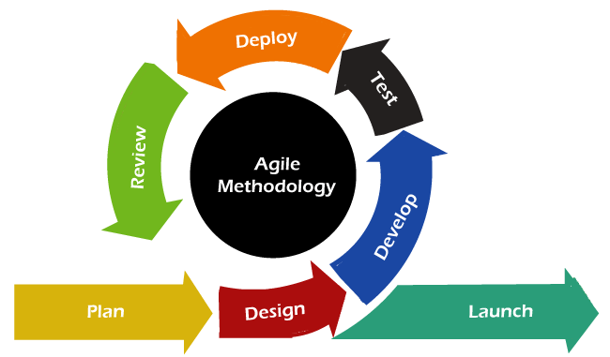

Figure 1 Agile Methodology

## Other Methodologies

### Waterfall Model

The Waterfall model is a traditional, linear approach to software development where each phase must be completed before the next begins. It typically involves stages such as requirements gathering, system design, implementation, testing, deployment, and maintenance. It will not be a Priority due to its Rigidity and hesitation in adapting to change, Delayed Feedback, and Sequential Progression.

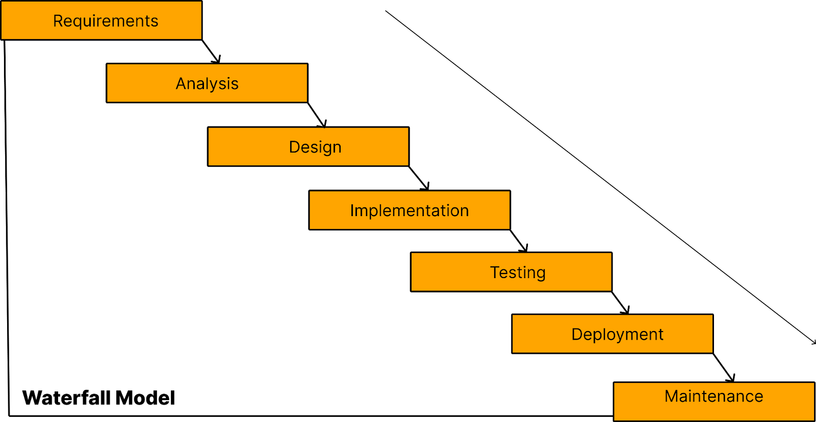

Figure 2 Waterfall Model

* + - 1. V-Shape Model (Verification and Validation)

The V-shape model is an extension of the Waterfall model where development and testing activities are planned in parallel. Each development stage has a corresponding testing phase, ensuring that verification and validation occur simultaneously. This will not be utilized due to Similar Rigidity to the Waterfall, Complexity in Implementation, and Late User Involvement.

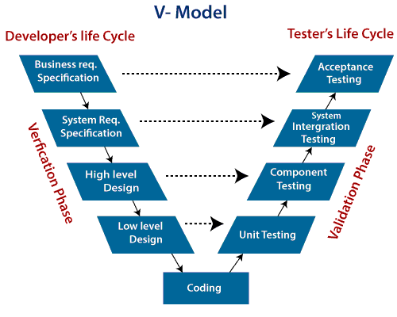

Figure 3 V Shape Model

### Spiral Model

The Spiral model combines iterative development with systematic aspects of the Waterfall model, emphasizing risk assessment and mitigation. It involves repeated cycles (spirals) of planning, risk analysis, engineering, and evaluation. However, this method will not be ideal for the design of the platform due to its complexity and cost nature, prone to management overhead, and unpredictable timelines.

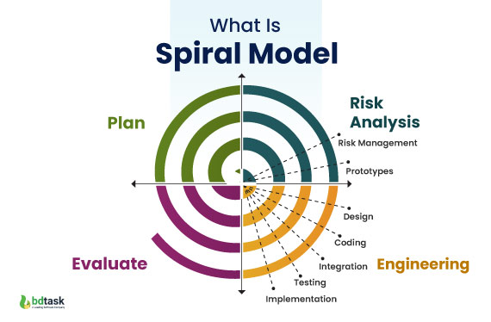

Figure 4 Spiral Model

### The System Architecture

The MVC (Model-View-Controller) architecture pattern is well-suited for implementing TutorFlux, providing a structured and modular approach for the development of the application.

1. **Model:** The model component represents the underlying data structures of TutorFlux, including user profiles, tutor listings, booking details, and course information. It also encapsulates the logic for interacting with the database, ensuring data consistency and integrity.
2. **View:** The view component is responsible for the user interface through which students and tutors interact with TutorFlux. This includes features for user registration, profile management, searching for tutors and courses, booking sessions, and view ratings and reviews. The views are designed to ensure a user-friendly and accessible interface for all users.
3. **Controller:** The controller component is an intermediary between the model and the view. It handles user inputs, processes requests, and coordinates interactions between the different components of the system. For example, when a student books a session with a tutor, the controller verifies availability, updates the booking status in the model, and refreshes the view to reflect the new booking.

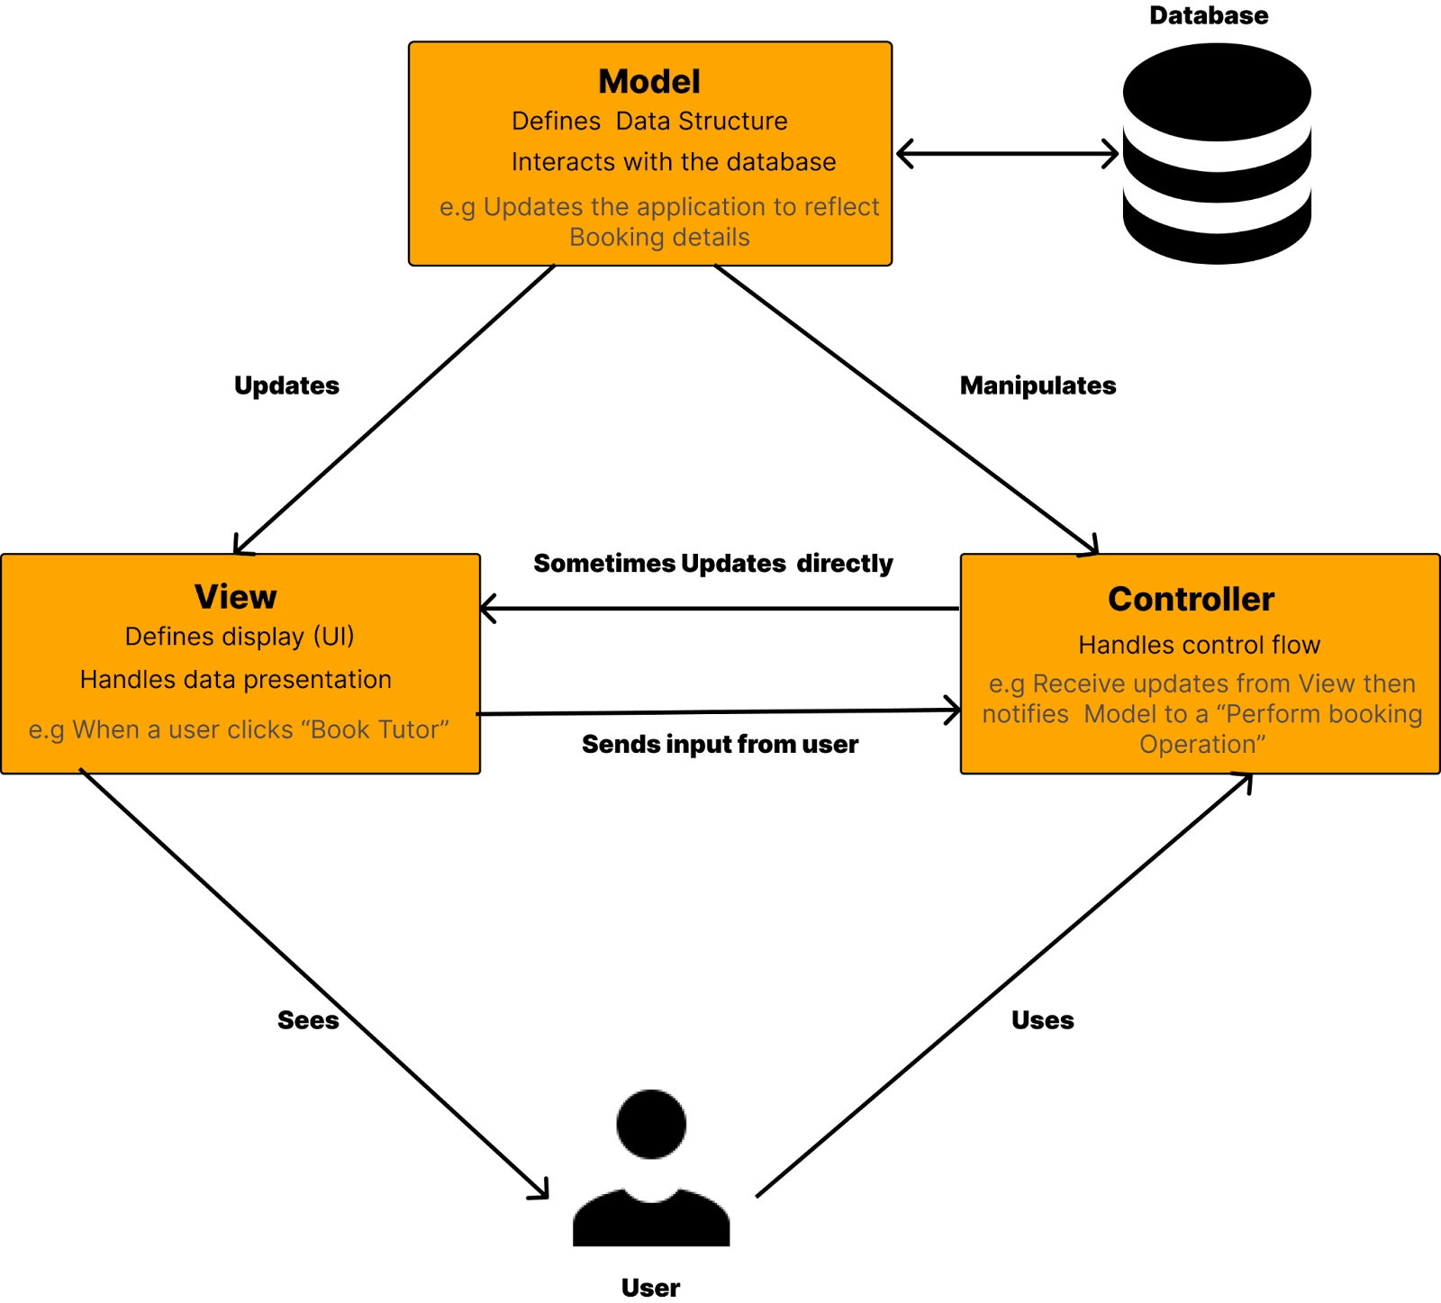

Figure 5 MVC Architecture Pattern

By following the MVC pattern, the development of TutorFlux will be more organized, maintainable, and scalable. Separating concerns according to MVC principles will facilitate a clearer delineation of responsibilities, making it easier to manage and extend the application. This structure ensures that the TutorFlux platform remains robust and adaptable, capable of evolving to meet the needs of its users.

# Project Planning and Scheduling

|  |  |  |  |
| --- | --- | --- | --- |
| **Phase** | **Description** | **Expected Deliverable** | **Timeline** |
| Project Initiation | Define project goals, team roles, and initial project scope. Set up project management tools and communication channels. | Initial Scope Document, Kick-off | July 9 - July 11 |
| Research and Requirements Gathering | Collect detailed requirements from stakeholders, conduct market research, and gather user stories. | Requirements Specification Document, User Stories | July 12 - July 18 |
| System Design | Design system architecture, design wireframes, and database schemas. Plan user interface and user experience. | System Architecture Diagram, Wireframes, Database Schema, UI/UX Design | July 19 - July 25 |
| Development | Implement the system's features and functionalities based on the design. Use iterative sprints for continuous development and integration. | Working Software Increments, Source Code Repository | July 26 - August 20 |
| Testing and Quality Assurance | Perform unit, integration, and user acceptance testing to identify and fix bugs. Ensure the system meets the defined requirements and is of high quality. | Test Plans, Test Cases, Bug Reports, Test Summary Report | August 21 - August 27 |
| Deployment and Launching | Deploy the application to a live environment. Ensure all deployment steps are followed and the system is accessible to users. | Deployment Plan, Live System, Launch Announcement | August 28 - August 30 |
| Post-Launch Support and Maintenance | Provide ongoing support, monitor system performance, and make necessary updates and improvements. | Support Plan, Maintenance Log, User Feedback Reports | August 31 - September 8 |

Table 1 TutorFlux Plan

# Tools and Technologies

The development of TutorFlux involves the integration of various tools and technologies to ensure robust, scalable, and user-friendly applications. Here, we will discuss the primary tools and technologies utilized across different aspects of the project. These tools would be broken down into two main classes comprising Hardware and Software tools

* + 1. Hardware tools

Developing TutorFlux, a comprehensive tutor booking application, requires specific hardware to ensure efficient and effective development, testing, and deployment. A Development Workstations Comprising a computer or laptop with an Intel Core i5 or AMD Ryzen 5 (or higher) Processor, 16 GB RAM or higher recommended for smoother multitasking, 512 GB SSD recommended for faster read/write speeds, and sufficient storage, sufficient Integrated graphics such as NVIDIA GTX 1650 or equivalent will be recommended for tasks involving graphical processing, 1080p Full HD monitor for increased productivity, Windows 10/11, macOS, or a popular Linux distribution. A range of Android and iOS devices to test app compatibility and performance across different models and operating systems. A modem with internet connectivity for third-party tools and further research.

* + 1. Software tools and technologies
       1. Development Tools

Integrated Development Environments (IDEs): Visual Studio Code (VS Code) is a free source code editor developed by Microsoft for Windows, macOS, and Linux. This IDE will be used for frontend and backend development due to its versatility and extensive plugin support with an integrated terminal. Android Studio was used for mobile development to leverage its powerful debugging and performance analysis tools making it popular among developers for its efficiency and ease of use.

Frontend Development: This project will use HTML, CSS, and JavaScript to design and create the user interface for the tutor booking application. The frontend code will be arranged into separate files for better maintainability. Frameworks like React.js will be utilized to build interactive and dynamic user interfaces, especially since the system requires complex interactions.

Backend Development: A server-side environment will be set up using Node.js, which allows JavaScript to run on the server. - Design and implement APIs (Application Programming Interfaces) for handling CRUD (Create, Read, Update, and Delete) operations related to sessions and bookings. Implementation of authentication and authorization mechanisms to ensure secure access to sensitive data.

* + - 1. Design Tools

Figma will be used to create wireframes and interactive prototypes. These tools allowed for rapid design iterations and user feedback incorporation. Star UML and Lucid chart would be used for creating use case diagrams, ERDs, Sequence diagrams, state diagrams, and class diagrams. These tools would provide a collaborative environment for visualizing and refining system design.

* + - 1. Testing Tools

Unit Testing: Jest and Mocha would be used for backend unit tests to ensure individual components functioned correctly.

Integration Testing: Postman and Insomnia would be used for API testing to verify the interaction between different system components.

User Acceptance Testing (UAT): UAT will be conducted with selected users to validate the application against the defined requirements and gather feedback for further improvements.

Deployment: Deploy the frontend and backend applications to a web server. - Ensure proper configuration and security measures are in place for the production environment.

### Version Control and Collaboration

Git and GitHub would be used for version control and collaboration providing a centralized repository and version history for the project. Git would be used for version control, allowing the development team to track changes, collaborate efficiently, and maintain code integrity. GitHub hosts the project’s repository, providing a platform for collaboration, issue tracking, and continuous integration.

### Programming Languages and Frameworks

TutorFlux will leverage modern web programming languages and frameworks to create a robust and scalable tutor booking application. The core technologies include:

* **HTML and CSS:** These foundational web technologies will be used for structuring and styling the application's user interface, ensuring a responsive and visually appealing design.
* **JavaScript:** As the primary scripting language, JavaScript will handle client-side logic, interactions, and asynchronous operations. ES6+ features will be utilized to write clean and efficient code.
* **React.js:** This popular JavaScript library will be employed for building the user interface components. Its component-based architecture and state management capabilities make it ideal for creating dynamic and interactive user experiences.
* **Node.js:** On the server side, Node.js will be used to build scalable and high-performance backend services. Its event-driven, non-blocking I/O model ensures efficient handling of multiple concurrent connections.
* **Express.js:** As a minimal and flexible Node.js web application framework, Express.js will be used to develop the API endpoints, manage routing, and handle server-side logic.

### Database

**MongoDB and Redis:**

For the TutorFlux project, MongoDB is selected as the primary database management system due to its flexibility, scalability, and ability to handle unstructured data. As a NoSQL database, MongoDB allows for the storage of data in a document-oriented format, which is ideal for managing the diverse data structures associated with user profiles, tutor listings, booking details, and more. MongoDB's schema-less design enables easy updates and expansions of the database as the application evolves, making it well-suited for the dynamic needs of TutorFlux.

In addition to MongoDB, Redis (version 3.9.2.6) is utilized as an in-memory data structure store. Redis is known for its high performance and low latency, making it an excellent choice for caching frequently accessed data, managing sessions, and handling real-time data processing within the application. The combination of MongoDB for persistent storage and Redis for caching and rapid data access ensures that TutorFlux can deliver a responsive and efficient user experience

### Payment Gateway Integration

MTN Mobile Money and Orange Money: These are popular mobile payment solutions in Cameroon and other African Countries, providing users with accessible and convenient payment methods.

Stripe: Stripe is integrated for secure and reliable payment processing. It handles transactions, stores payment details, and ensures compliance with international payment standards, which is crucial for the booking and payment functionalities of TutorFlux.

* + - 1. Real-time Communication

**WebRTC:** WebRTC (Web Real-Time Communication) is an open-source project that enables real-time audio, video, and data sharing capabilities directly between web browsers and mobile applications. It is used for enabling real-time tutoring sessions in TutorFlux.

* + - 1. Colour Scheme and Font

The colour scheme for TutorFlux was designed to be visually appealing and user-friendly.

The fonts used in TutorFlux were selected to be clear and readable, enhancing the user experience. The primary fonts include Poppins used for its clean and modern appearance, providing excellent readability across different devices, and Open sans offering a friendly and approachable feel, making it ideal for an educational tutoring platform.

The combination of these tools and technologies would provide a comprehensive and efficient development environment for TutorFlux. Each tool and technology has been chosen for its specific strengths and how it contributes to the overall goals of creating a reliable, scalable, and user-friendly tutor booking application. This strategic selection would ensure that TutorFlux meets the high standards expected by its users and stakeholders, delivering a seamless and effective solution for private tutoring.

* 1. Ethical Considerations

Ensuring ethical standards was paramount throughout the development and research process of TutorFlux. The following measures were taken to address ethical considerations:

Informed Consent: Participants in the Google Forms survey were informed about the purpose of the study, their rights, and how their data would be used. Consent was obtained before collecting any information.

Data Privacy and Security: All collected data was anonymized and stored securely to protect participant confidentiality. Data encryption and secure storage practices were implemented to safeguard sensitive information.

Bias Reduction: Efforts were made to minimize bias in data collection and analysis. This included designing the questionnaire to be neutral and avoiding leading questions that could influence responses.

* 1. Conclusion

Chapter 3 has provided a comprehensive overview of the methodology employed in the development of TutorFlux. The project adopted an Agile SDLC approach, ensuring flexibility and continuous improvement throughout the development cycle. A combination of primary and secondary data collection methods provided valuable insights into user needs and preferences. The system architecture provides an overview of the system logic. The use of modern tools and technologies ensured an efficient and scalable application. Rigorous testing and quality assurance processes validated the functionality and performance of the system. Ethical considerations were addressed to ensure the integrity and privacy of participant data. The next chapter will delve into the analysis of collected requirements data, design and implementation details, and results of the TutorFlux project, demonstrating how the methodology outlined here contributed to the successful development of the application.

# CHAPTER 4

# ANALYSIS, DESIGN, IMPLEMENTATION AND FINDINGS

# Introduction

This chapter delves into the practical execution of the methodology outlined in Chapter 3 above, focusing on developing and implementing the Tutor booking application (TutorFlux) to streamline learning processes. It covers the statistical analysis of data collected to validate the concept and user experience, a thorough analysis of gathered requirements, and the system's design specifications. The implementation phase utilizes the tools and techniques specified in the methodology, followed by rigorous testing to ensure quality and functionality. Finally, the chapter reports the findings and results of the development process, providing a comprehensive overview of the project’s progress and outcomes. This chapter is crucial in translating theoretical planning into actionable and measurable results, highlighting the effectiveness of the Agile SDLC methodology in delivering a user-centric and functional tutor booking application.

# Statistical Analysis

## Analysis of Collected Data

To evaluate the viability and user experience of TutorFlux, we conducted a survey targeting potential users, including students and tutors. The survey aimed to gather insights into user needs, preferences, and the overall acceptance of the TutorFlux concept. The sample size was estimated to be as large as possible exceeding 50 participants. However, we were able to reach out to 62 active collaborators and participants who greatly provided viable data for this project.

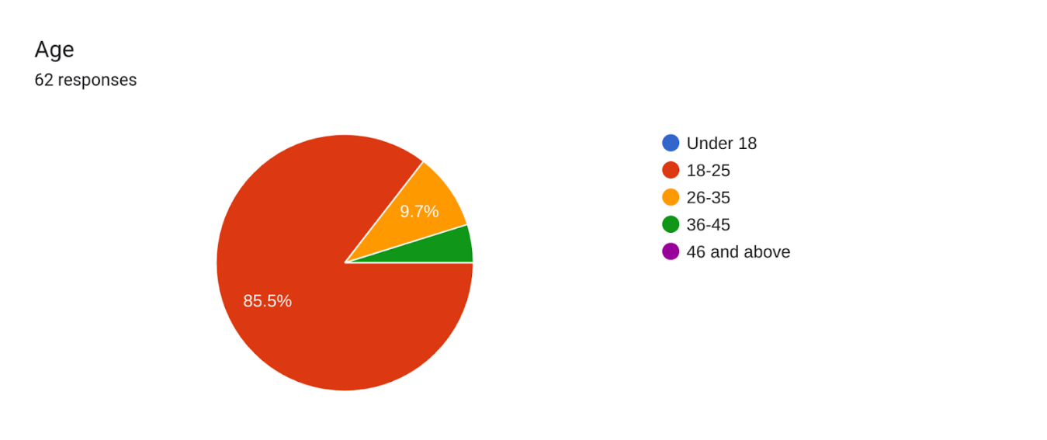

Figure 6 : Survey Question 1

The first survey question indicates the demographic age range of participants showing that 85.5% of these active participants were within the age range of 18 years to 25 years and were classified as youths, 9.7% within the age range of 26 years to 35 years as young adults, and the remaining 4.8% indicate adults within the age range of 36years to 45years. This shows the inclusion of the active population in this project.

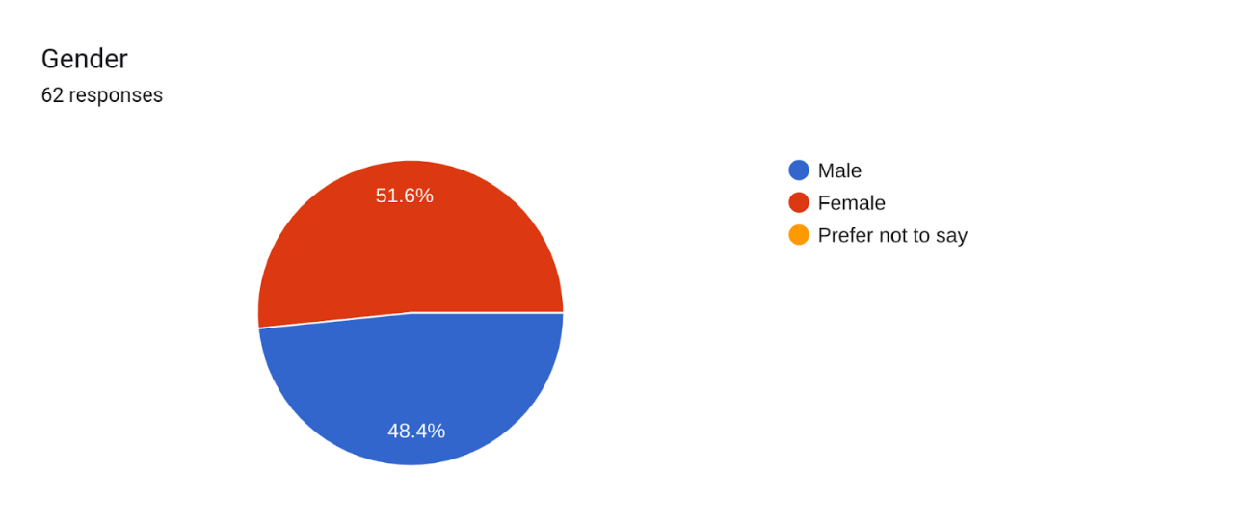

Figure 7 : Survey Question 2

The second survey question shows that 51.6% of the participants were of the female gender and 48.4 of the male gender indicating the involvement of both genders in the drive for innovation and transformation of the tutoring sector.

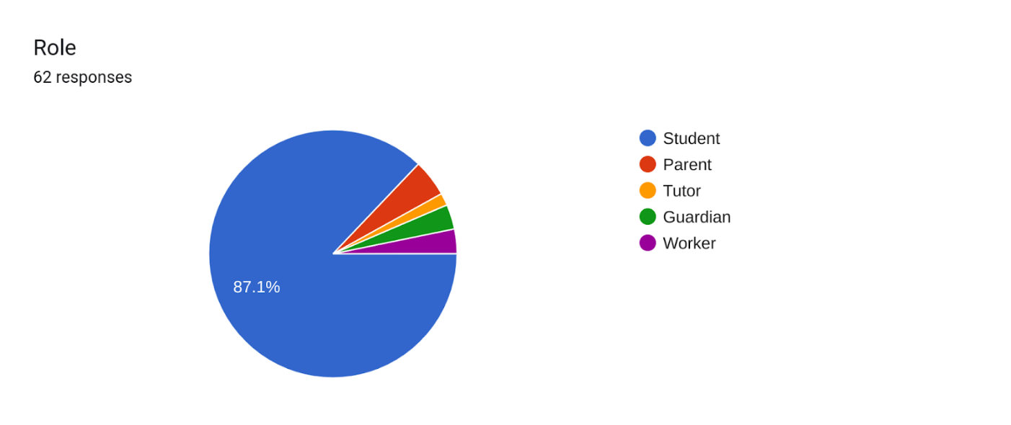

Figure 8 : Survey Question 3

The third survey question highlights the diverse group of participants which included students, parents, tutors, guardians, and workers. Importantly, it shows that students constituted the majority, accounting for 87.1% of the respondents. This majority representation suggests that the survey findings are heavily influenced by the student perspective, which can provide valuable insights into their needs and experiences.

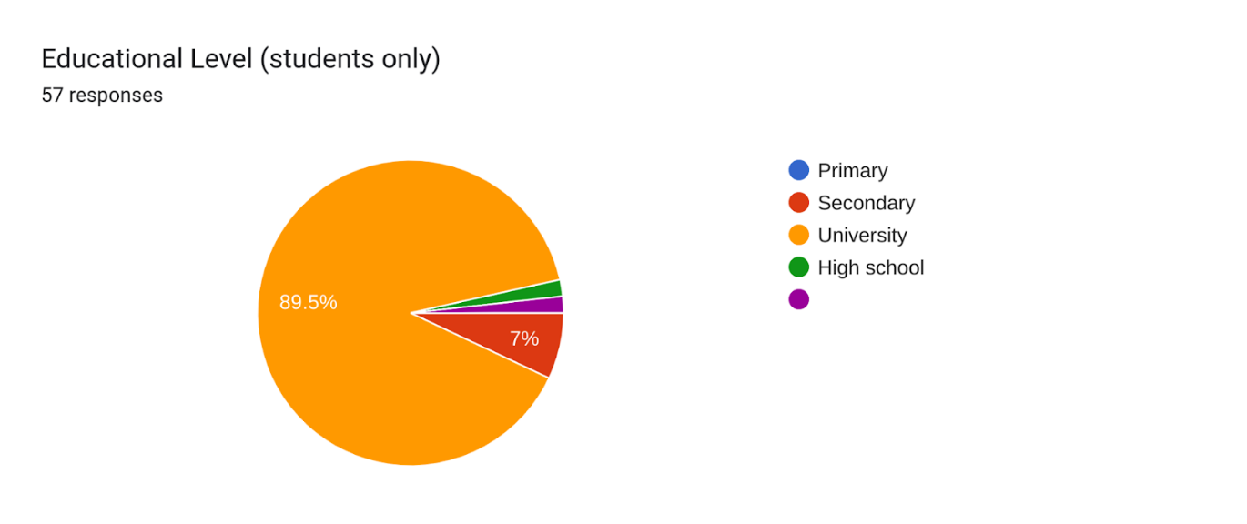

Figure 9 : Survey Question 4

The fourth survey question indicates that 89.5% of the participants who are students are undergraduates at the University level being the predominant size for the participants, the other 7% shows the involvement of secondary school students seeking to provide insights into their needs when it comes to academics as well.

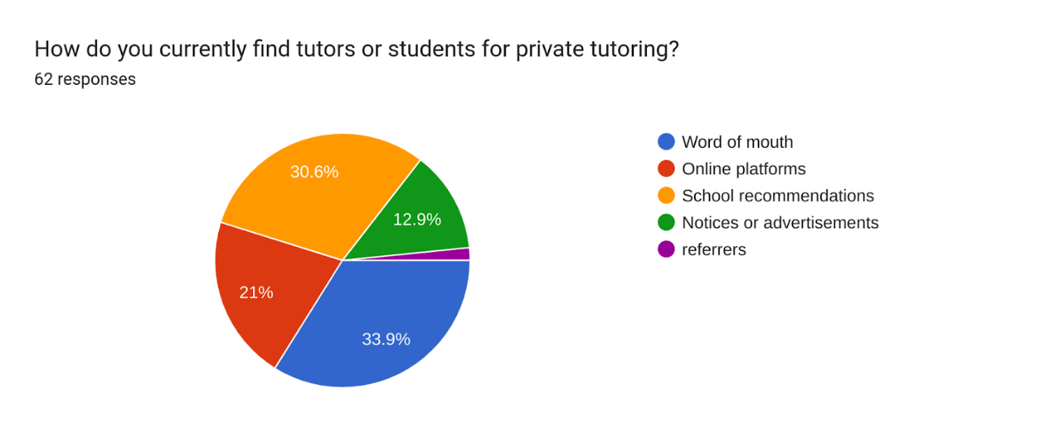

Figure 10 : Survey Question 5

The fifth survey question sought to find out how tutors find students who need their assistance as well as students locating tutors when they are in need. Responses indicate that 33.9% of tutor-student findings are achieved through the local method of word-of-mouth referrals. That is you ask about tutors to your fellow neighbour and if someone finds one he/she suggests it to you. This method however is always time-consuming. 30.6% shows the contribution of schools in recommending tutors to students and vice versa. 21% shows how online platforms themselves facilitate tutor finding and then 12.9% through notices and advertisements.

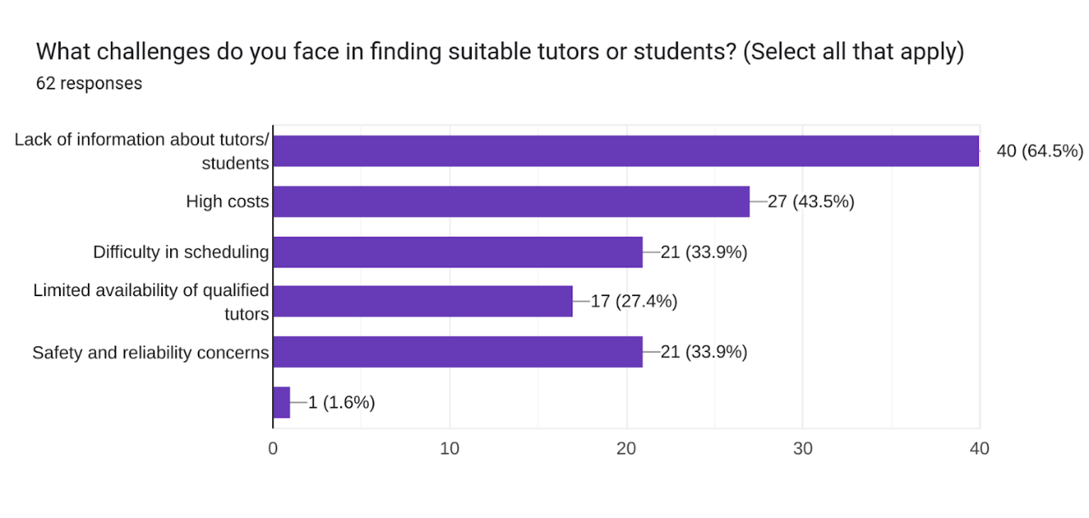

Figure 11 : Survey Question 6

The sixth survey question shows that the prioritized challenge faced in finding tutors is due to lack of information about tutors/students. This challenge shows great significance with a percentage of 64.5% followed by the high cost with a percentage of 43.5. Safety and reliability concerns as well as difficulty in scheduling are signified by a percentage of 33.9 each and the last but also important challenge is the limited availability of qualified tutors.

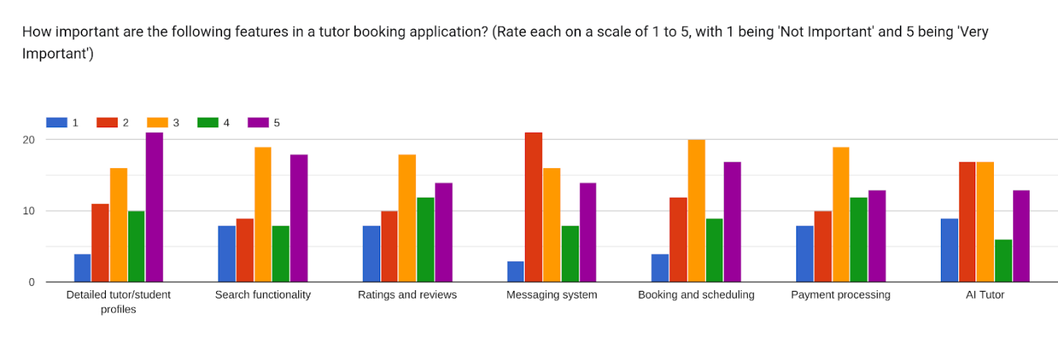

Figure 12 : Survey Question 7

Question 7 shows the ratings of features within an application. However, from our responses, the detailed tutor/student profile is a very important feature followed by search functionality features.

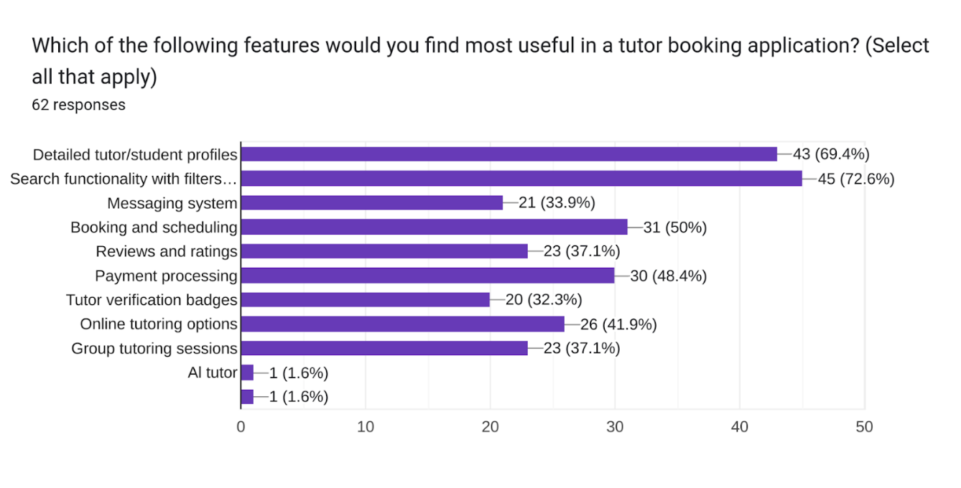

Figure 13 : Survey Question 8

Question 8 shows the most prioritized functionality being search functionalities with filters with a percentage of 72.6, ability to view detailed profiles with a percentage of 69.4, Booking and scheduling of 50%, Payment processing of 48.4 and other significant functionalities as indicated by the bar chart above.

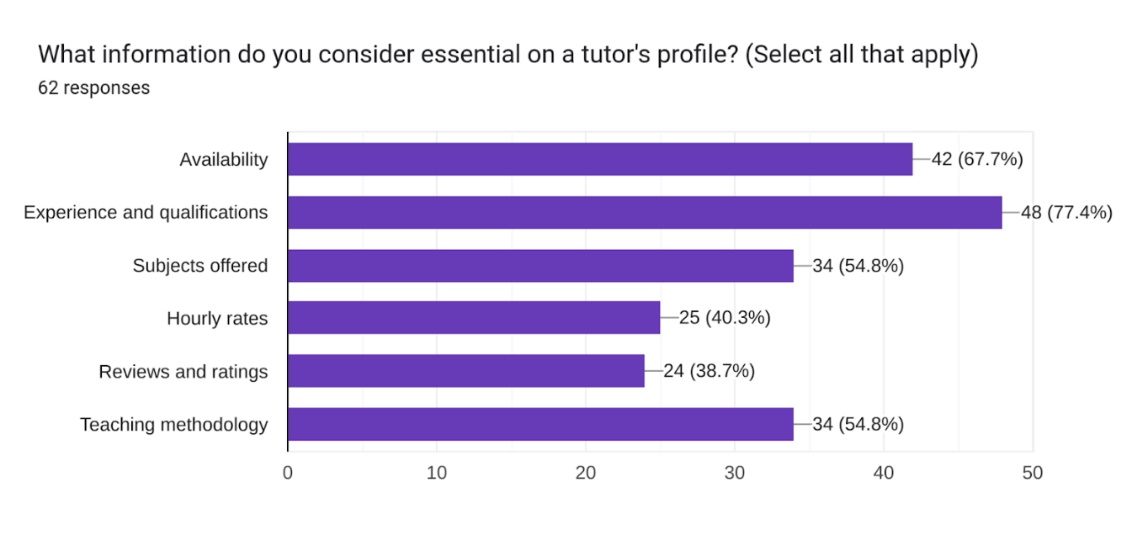

Figure 14: Survey Question 9

Question 9 sought to find out the essential information students are more concerned with regarding a tutor’s profile. Responses indicated that the prioritized information is the tutor's experience and qualification levels.

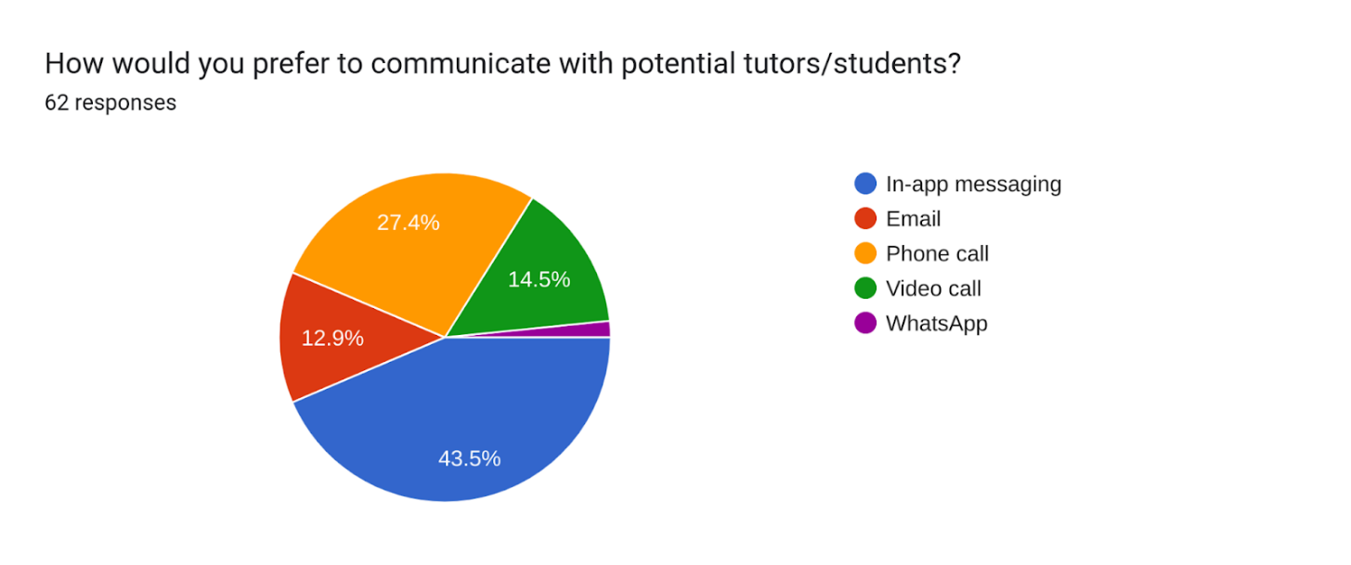

Figure 15 : Survey Question 10

Question 10 indicates that 43.5% of the surveyed population preferred in-app messaging as a means of communication within the tutor booking application.

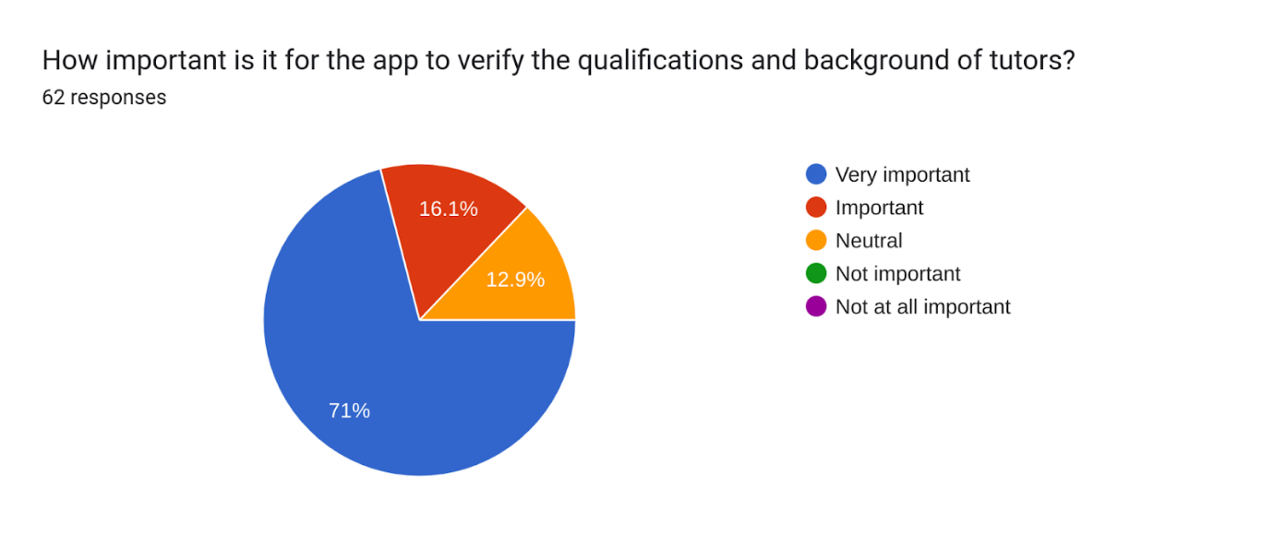

Figure 16 : Survey Question 11

The pie chart in question 11 supports the functionality of tutor profile verification in terms of qualification with a 71% to be a very important initiative backing up the experience and qualification feature above.

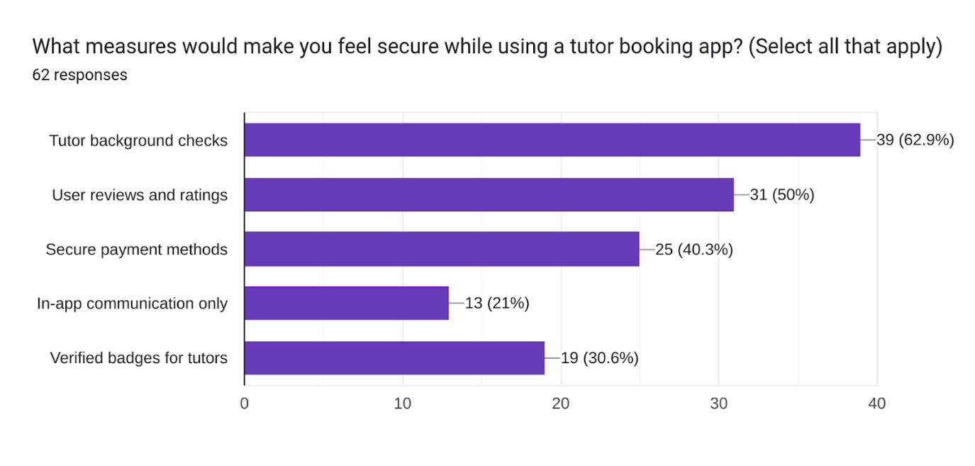

Figure 17 : Survey Question 12

Question 12 sought to find out how to provide a secure environment. However, everything turned to face towards tutor background checks with high significance indicating that verified tutors pave the way for a secured and reliable platform.

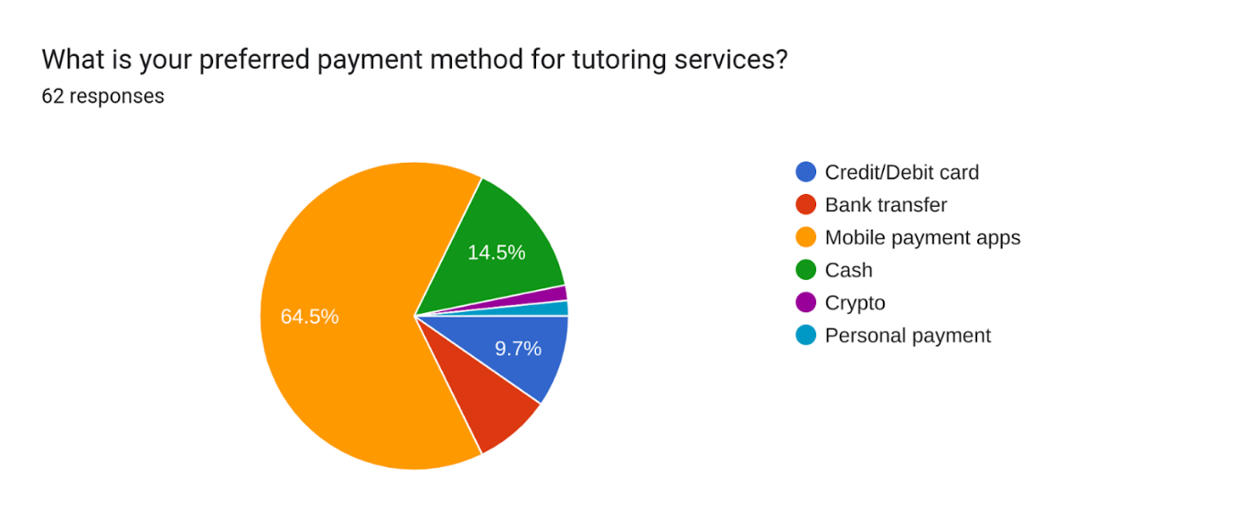

Figure 18 : Survey Question 13

Question 13 provides us with a population's choice of payment to be the utilization of mobile money payments with high significance.

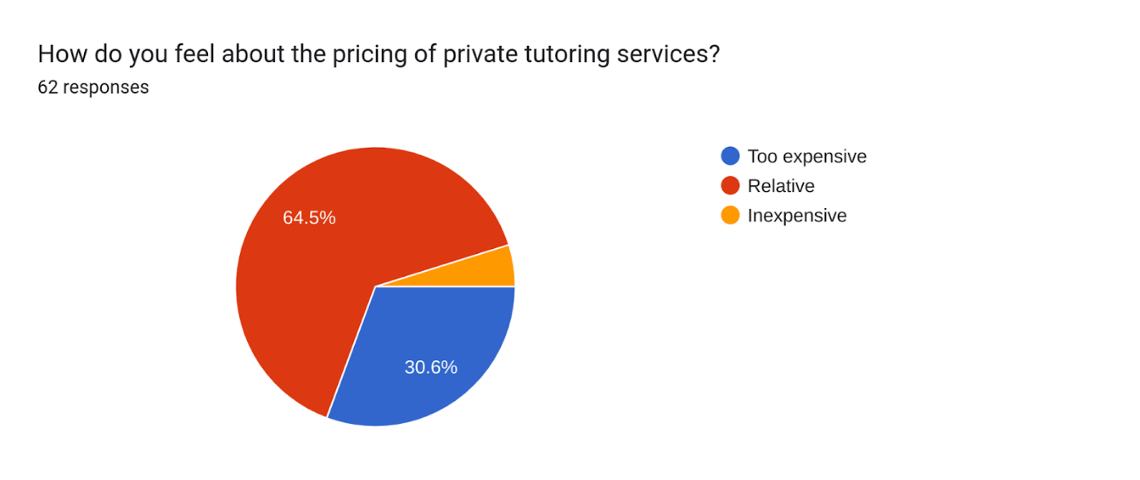

Figure 19 : Survey Question 14

Question 14 indicates that the pricing of tutoring services is relative to the services provided as proposed by the pie chart with a percentage of 64.5%. This shows that students are not often exploited but rather the services they receive are worth the cost they incurred. However, there is still a significant proportion of 30.6% dissatisfaction with the pricing by other individuals or groups of individuals.

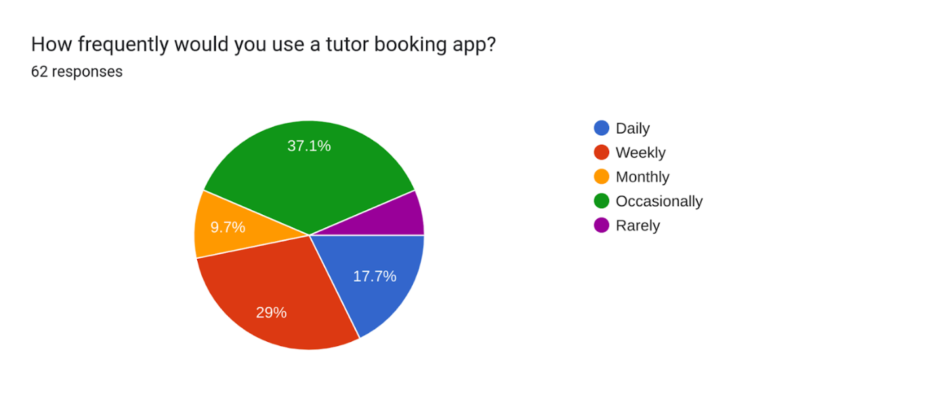

Figure 20 : Survey Question 15

Question 15 shows that the application would be occasionally used in times of challenges faced by the students. However, the application would be of great usage as indicated by the chart, as a significant population will be willing to use the application based on their time preferences and frequencies.

## Analysis of Requirements Gathered

The requirements analysis outlines the functional and non-functional requirements for TutorFlux, a centralized tutor booking application designed to streamline learning processes. It provides a detailed description of the application's functionalities to ensure a clear understanding of the system's capabilities. TutorFlux is a tutor booking platform that connects students with tutors. It provides features for searching, booking, and managing tutoring sessions. The platform will support various subjects and learning levels, ensuring a comprehensive solution for students and tutors.

### **Functional Requirements**

This section outlines the detailed functional requirements for TutorFlux, specifying the features and capabilities essential for the platform's functionality. Each functionality is explained to clarify its purpose, functionality, and user interaction.

* Registration Module

Sign Up: Users can register by providing personal details such as email, name, address, and contact number. This process establishes an intuitive environment with profile matches when searching for tutors, ensuring personalized recommendations and easy user on boarding.

Login: Users can log in using their registered credentials, ensuring secure access to their accounts.

Password Recovery: Users can recover their passwords through a secure email link, enabling easy account recovery and enhancing user security.

* Profile Management

Student Profile: Students can create and update their profiles, including personal information and learning preferences. This feature allows students to set their educational goals, preferred subjects, and learning styles, facilitating better tutor matching.

Tutor Profile: Tutors can create and update their profiles with personal information, subjects taught, qualifications, availability, and hourly rates. This helps students make informed decisions by viewing detailed tutor profiles.

* View Available Tutors and Courses

Display Available Tutors: Students can view detailed profiles of available tutors, including qualifications, subjects taught, ratings, and availability.

Display Available Courses: Tutors can showcase the courses they offer, including course descriptions, duration, and pricing, making it easier for students to find suitable courses.

* Search and Filter

Search Functionality: Students can search for tutors based on subjects, location, availability, and ratings, allowing them to find suitable tutors quickly.

Filters: Students can apply filters to narrow down search results, enhancing the user experience by presenting relevant options based on their criteria.

* Ratings and Reviews

Rating System: Students can rate and review tutors after sessions, providing valuable feedback and helping future students make informed decisions.

View Ratings and Reviews: Users can view tutor ratings and reviews, ensuring transparency and trust in the tutor selection process.

* Order and Payment History

Transaction History: Users can view their complete transaction history, including payment details and session fees, providing a clear record of their financial activities.

Session History Users can view their completed and upcoming sessions, helping them keep track of their tutoring schedule.

* Homework and Test Module

Assign Homework: Tutors can assign homework to students, enabling continuous learning and assessment outside of tutoring sessions.

Create and Assign Tests: Tutors can create and assign tests to students, who can then submit their work online. Tutors can grade these tests, providing feedback and tracking student progress.

* Communication Module

Audio, Video, and Text Chat: Enable real-time audio, video, and text chat communication between students and tutors, enhancing interaction and support.

File Sharing: Support file sharing within the chat system, allowing students and tutors to exchange documents, assignments, and study materials seamlessly.

* Payment Module

Integrate with MTN Mobile Money, Orange Money, credit cards, and other secure payment gateways. This ensures the safe handling of payments, refunds, and transactions, providing a seamless payment experience.

* Session Booking Module

Book Sessions: Students can book tutoring sessions based on tutor availability. This feature allows easy scheduling and ensures tutors' availability is up-to-date.

Manage Bookings: Both students and tutors can view, reschedule, or cancel sessions. Users can view their completed and upcoming bookings, and tutors can accept or reject booking requests.

* Set Availability

Tutors can set their availability for tutoring sessions, ensuring students can book sessions during designated times. This feature helps maintain a structured and organized schedule.

* Course Management

Tutors can manage the courses they offer, including setting course prices, duration, and content. This feature allows tutors to organize their teaching material effectively.

* Student Management

Tutors can manage their students, view profiles, and track their progress. This feature supports personalized learning and helps tutors monitor student development.

* Automated Assistance

Provide AI-based tutoring assistance for students, using machine learning to tailor learning experiences based on individual needs. This feature aims to enhance learning efficiency and provide supplemental support.

* Auto GPS Location

Automatically detect user location to find nearby tutors. This feature ensures that tutors’ and students’ locations are visible, enhancing proximity-based searches, and ensuring convenience and trust in local tutor searches.

* Admin Module

User Management: Admins can manage student and tutor profiles, ensuring all user information is accurate and up-to-date.

Content Management: Admins can manage subjects, categories, and other content, maintaining the platform’s educational resources.

Session Monitoring: Admins can monitor and manage tutoring sessions, ensuring quality and compliance with platform standards.

Reports and Analytics: Admins can generate reports on user activity, session statistics, and financial transactions, providing insights for performance evaluation and strategic planning.

### **Non-Functional Requirements**

* Performance Requirements

Concurrency and Scalability: The system should be able to handle up to 10,000 concurrent users without degradation in performance. This includes students searching for tutors, booking sessions, engaging in in-app communication, and tutors managing their schedules and conducting sessions.

Response Time: Any action performed by the user for example searching for tutors, booking sessions, or making payments should have a least minimal response time. This ensures a smooth and responsive user experience.

Optimization: Utilize Redis caching mechanisms to store frequently accessed data and reduce the load on the database. Optimize database queries and use indexes where necessary to improve query performance.

* Security Requirements

Data Encryption: All sensitive data, such as user credentials, personal information, and payment details, must be encrypted both in transit and at rest. This prevents unauthorized access and ensures data privacy.

Authentication and Authorization: Implement secure authentication mechanisms to verify user identities. Use multi-factor authentication (MFA) to add an extra layer of security.

Role-Based Access Control (RBAC): Define and enforce roles and permissions to ensure users have access only to the resources they are authorized to use. Separate roles for students, tutors, and admins should be clearly defined.

Security Audits and Assessments: Conduct regular security audits and vulnerability assessments to identify and mitigate potential security risks.

Compliance: Ensure the system complies with relevant security standards and regulations depending on the geographical location and data sensitivity.

* Usability Requirements

The UI must be intuitive and user-friendly, allowing users to easily navigate the application and perform desired actions without extensive training or support. Ensure the UI is responsive and works seamlessly across different devices (desktops, tablets, and smartphones) and screen sizes. Provide comprehensive user support, including user guides, and a helpdesk to assist users with any issues they may encounter.

* Reliability Requirements

Ensure the system has an uptime of 99.9%, minimizing downtime and ensuring continuous availability. This can be achieved through redundancy, failover mechanisms, and regular maintenance to continuously monitor system performance and quickly detect and resolve issues. Implement regular automated backups of all critical data to prevent data loss. Store backups in multiple locations to ensure redundancy. Develop and maintain a comprehensive disaster recovery plan to quickly restore services in the event of a system failure or data breach.

# **DESIGN**

## **UML Diagrams**

Unified Modelling Language (UML) is a standardized modelling language widely used in software engineering. UML diagrams help visualize, specify, construct, and document the artefacts of a software system. They encompass a variety of diagrams such as flowcharts, class diagrams, use case diagrams, and sequence diagrams, each providing a unique perspective on the system's architecture and behaviour.

## Flowchart Diagram

Flowchart diagrams visually represent processes, workflows, or systems using standardized symbols. They illustrate the sequence of steps or actions required to complete a task or reach a decision. The main symbols used in flowcharts include:

Ovals: Indicate the start and end points of a process.

Rectangles: Represent process steps or actions.

Diamonds: Denote decision points that lead to different paths based on conditions or yes/no questions.

Arrows: Indicate the flow, relationship, or direction from one step to another.

**Objectives of a Flowchart Diagram**

1. Clarify Complex Processes: Breaking down a process into its component steps makes it easier to understand and analyse complex workflows.

2. Amplify Communication: Visual representations facilitate clearer communication among team members, stakeholders, or any audience, providing a common understanding of the process.

3. Identify Problematic Areas: Pinpoint inefficiencies, bottlenecks, or problem areas within a process that may need improvement.

4. Standardize Processes: Document and standardize procedures, ensuring everyone follows the same steps in the correct order.

5. Aid in Training and on boarding: Help new employees or team members quickly learn processes through visual flowcharts, making training and adaptability more efficient.

6. Support Decision Making: Map out possible decision points and outcomes, assisting in evaluating different scenarios and making informed decisions.

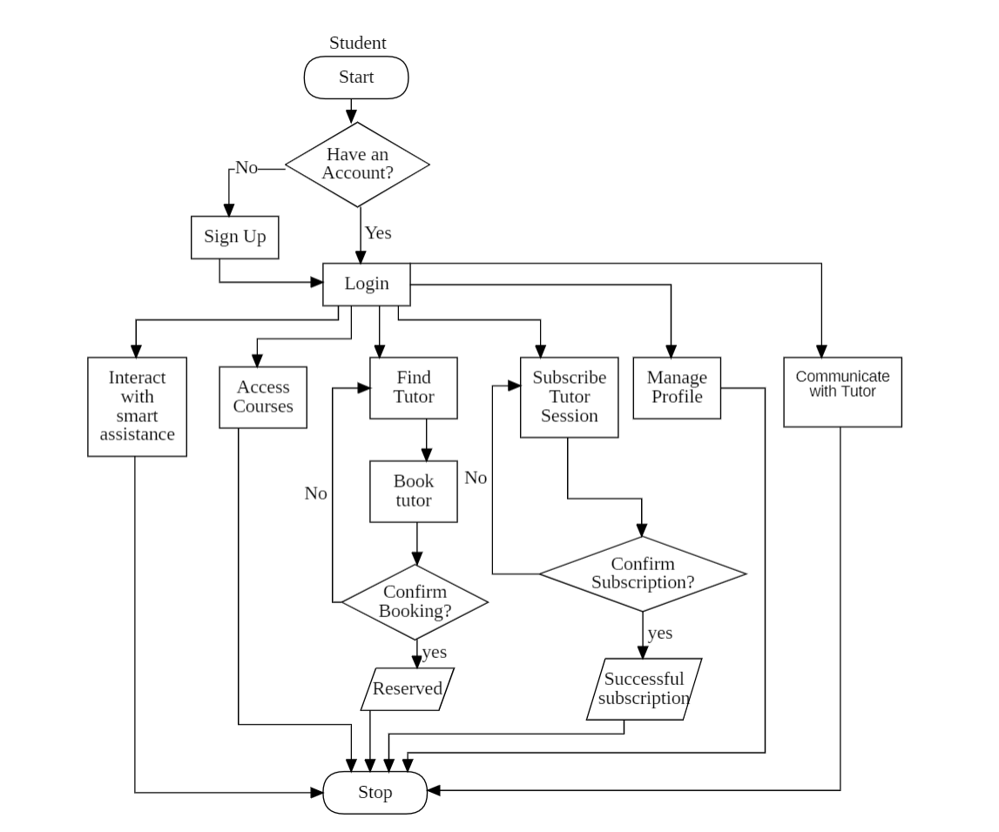

Figure 21 : Student Flow Chart

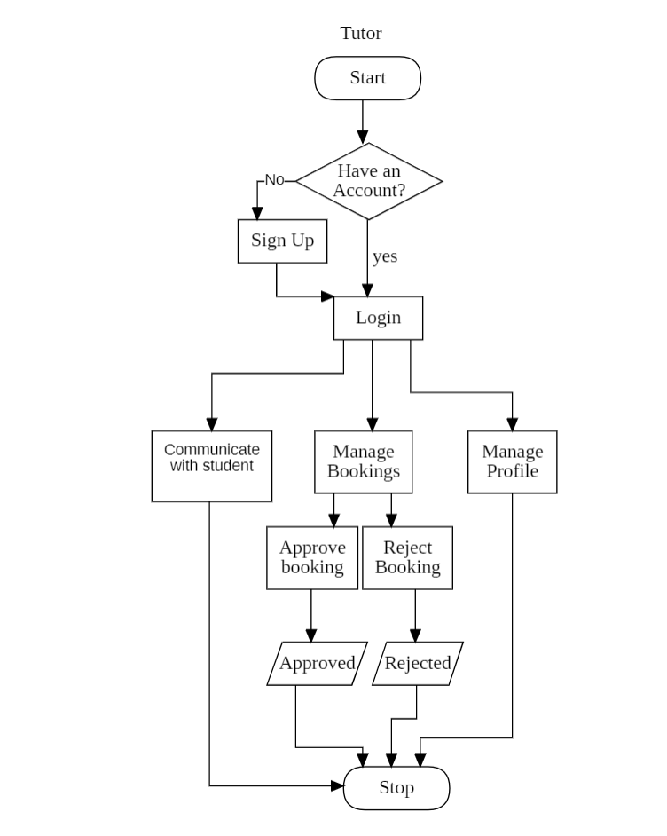

Figure 22 : Tutor Flow Chart

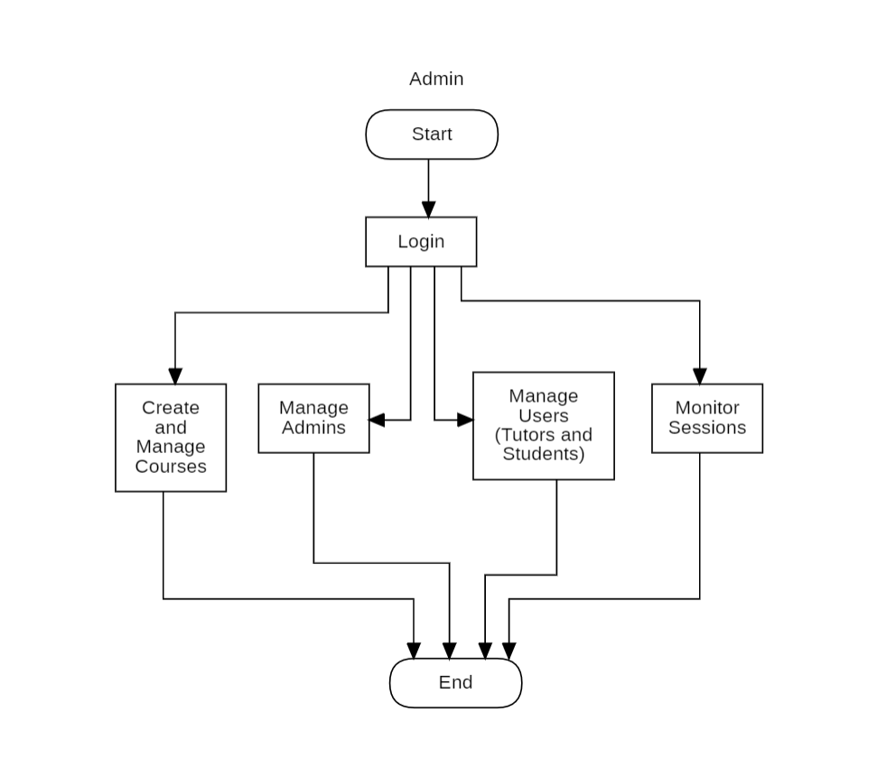

Figure 23 : Admin Flow Chart

## **Use Case Diagram**

A use case diagram visually represents how users interact with a system. It shows the relationship between users (actors) and different use cases, which represent specific functionalities or actions of the system. The purpose is to provide a high-level overview of the system's functionality and help stakeholders understand user interactions.

**Use Case Descriptions for TutorFlux**

* **Sign Up (Register)**

**Actor:** Student, Tutor  
**Description:** Users can register by providing their email, name, address, and contact information as well as other key information deemed important within the system.  
**Preconditions:** The user must have valid personal credentials.  
**Post conditions:** A new user account is created and stored in the system.  
**Main Flow:**

User navigates to the sign-up page.

User enters required personal information.

System validates the information.

System creates a new user account.

System confirms the successful registration.

* **Login**

**Actor:** Student, Tutor  
**Description:** Users can log in using their credentials.  
**Preconditions:** The user must have a registered account.  
**Post conditions:** The user is authenticated and granted access to the system.  
**Main Flow:**

User navigates to the login page.

User enters email and password.

System verifies credentials.

System authenticates the user.

User is redirected to their dashboard.

* **Password Recovery**

**Actor:** Student, Tutor  
**Description:** Users can recover their passwords via email.  
**Preconditions:** The user must have a registered email address.  
**Post conditions:** The user receives an email with instructions to reset their password.  
**Main Flow:**

User navigates to the password recovery page.

User enters their registered email address.

System sends a password recovery email.

User follows instructions in the email to reset the password.

System updates the user's password.

* **Create/Update Student Profile**

**Actor:** Student  
**Description:** Students can create and update their profiles, including personal information and learning preferences.  
**Preconditions:** The student must be logged in.  
**Post conditions:** The student's profile is updated in the system.  
**Main Flow:**

Student navigates to the profile page.

Student enters or updates personal information.

System saves the updated profile information.

System confirms the profile update.

* **Create/Update Tutor Profile**

**Actor:** Tutor  
**Description:** Tutors can create and update their profiles, including personal information, subjects taught, qualifications, availability, and hourly rates.  
**Preconditions:** The tutor must be logged in.  
**Post conditions:** The tutor's profile is updated in the system.  
**Main Flow:**

Tutor navigates to the profile page.

Tutor enters or updates personal information.

System saves the updated profile information.

System confirms the profile update.

* **Search Tutors**

**Actor:** Student  
**Description:** Students can search for tutors based on subjects, location, availability, and ratings.  
**Preconditions:** The student must be logged in.  
**Post conditions:** The system displays a list of matching tutors.  
**Main Flow:**

Student navigates to the search page.

Student enters search criteria.

System processes the search request.

System displays matching tutors.

Student views tutor profiles.

* **Apply Filters**

**Actor:** Student  
**Description:** Students can apply filters to narrow down search results.  
**Preconditions:** The student must be logged in.  
**Post conditions:** The system displays filtered search results.  
**Main Flow:**

Student navigates to the tutors and courses page.

Student selects filters (e.g., location, availability).

System applies filters to search results.

System displays filtered results.

Student views filtered tutor profiles.

* **Book Session**

**Actor:** Student  
**Description:** Students can book tutoring sessions based on tutor availability.  
**Preconditions:** The student must be logged in and have a valid payment method.  
**Post conditions:** A tutoring session is booked and confirmed.  
**Main Flow:**

Student selects a tutor from the search results.

Student views tutor's availability.

Student selects a time slot and books a session.

System processes the booking request.

System confirms the booking and notifies the tutor.

* **Reschedule Session**

**Actor:** Student, Tutor  
**Description:** Students and tutors can reschedule booked sessions.  
**Preconditions:** The user must have a confirmed session.  
**Post conditions:** The session is rescheduled and updated in the system.  
**Main Flow:**

User navigates to the session management page.

User selects a session to reschedule.

User selects a new time slot.

System updates the session details.

System confirms the rescheduling and notifies both parties.

* **Reject Session**

**Actor:** Student, Tutor  
**Description:** Students and tutors can cancel booked sessions.  
**Preconditions:** The user must have a confirmed session.  
**Post conditions:** The session is cancelled and removed from the system.  
**Main Flow:**

User navigates to the session management page.

User selects a session to reject.

System processes the cancellation request.

System updates the session status.

System confirms the cancellation and notifies both parties.

* **View Session History**

**Actor:** Student, Tutor  
**Description:** Users can view their completed and upcoming sessions.  
**Preconditions:** The user must be logged in.  
**Post conditions:** The system displays the user's session history.  
**Main Flow:**

User navigates to the session history page.

System retrieves session data.

System displays completed and upcoming sessions.

User views session details

* **Audio, Video, and Text Chat**

**Actor:** Student, Tutor  
**Description:** Enable communication between students and tutors.  
**Preconditions:** Both users must have a confirmed session.  
**Post conditions:** Users can communicate via the selected medium.  
**Main Flow:**

User initiates a chat session.

System establishes the connection.

Users communicate via audio, video, or text chat.

System supports file sharing if needed.

Users end the chat session.

* **Assign Homework and Tests**

**Actor:** Tutor  
**Description:** Tutors can assign homework and tests to students.  
**Preconditions:** The tutor must have an active student session.  
**Post conditions:** Homework and tests are assigned to students.  
**Main Flow:**

Tutor navigates to the homework/test management page.

Tutor creates a new homework/test assignment.

Tutor assigns the homework/test to students.

System notifies students of the new assignment.

* **Submit Homework and Tests**

**Actor:** Student  
**Description:** Students can submit their homework and tests.  
**Preconditions:** The student must have received an assignment.  
**Post conditions:** The homework/test is submitted for grading.  
**Main Flow:**

Student navigates to the assignment submission page.

Student uploads the completed homework/test.

System processes the submission.

System confirms the submission and notifies the tutor.

* **Rate and Review Tutors**

**Actor:** Student  
**Description:** Students can rate and review tutors after sessions.  
**Preconditions:** The student must have completed a session.  
**Post conditions:** The rating and review are saved in the system.  
**Main Flow:**

Student navigates to the session history page.

Student selects a completed session.

Student rates the tutor and writes a review.

System saves the rating and review.

System updates the tutor’s overall rating.

* **Access Smart Assistant**

**Actor:** Student  
**Description:** Students can access the Fluxai assistance for study enhancement.  
**Preconditions:** The student must have an account within the system and must be logged in.  
**Post conditions:** The smart sessions are saved in the system.  
**Main Flow:**

Student navigates to the Fluxai page.

Student enters required info or data to enable a guided learning.

System process the imputed data.

System saves the session.

* **Content Management**

**Actor:** Admin

**Description:** Admins can manage the content on the platform, including subjects, categories, and other static information.

**Preconditions:** Admin must be logged in.

**Post conditions:** Content updates are reflected in the system.

**Main Flow:**

1. Admin logs into the system.

2. Admin navigates to the content management section.

3. Admin selects the content to add, update, or delete.

4. Admin makes the necessary changes.

5. System saves the changes and updates the content.

* **Monitor and Manage Tutoring Sessions**

**Actor:** Admin

**Description:** Admins can monitor live tutoring sessions and intervene if necessary to ensure compliance with platform policies.

**Preconditions:** Admin must be logged in.

**Post conditions:** Sessions are monitored and managed.

**Main Flow:**

1. Admin logs into the system.

2. Admin navigates to the session monitoring section.

3. Admin selects a session to monitor.

4. Admin intervenes if necessary.

5. System logs the admin’s actions.

* **Generate Reports**

**Actor:** Admin

**Description:** Admins can generate various reports on user activity, session statistics, and financial transactions.

**Preconditions:** Admin must be logged in.

**Post conditions:** Reports are generated and available for review.

**Main Flow:**

1. Admin logs into the system.

2. Admin navigates to the reports section.

3. Admin selects the type of report to generate.

4. Admin configures the report parameters.

5. System generates the report and displays it to the admin.

* **Financial Transactions Management**

**Actor:** Admin

**Description:** Admins can oversee and manage financial transactions, including payments and refunds.

**Preconditions:** Admin must be logged in.

**Postconditions:** Financial transactions are processed and recorded.

**Main Flow:**

1. Admin logs into the system.

2. Admin navigates to the financial transactions section.

3. Admin views recent transactions.

4. Admin processes any required refunds or payment issues.

5. System updates the financial records.

* **User Management**

**Actor:** Admin

**Description:** Admins can add, update, or delete user accounts, including setting user roles and permissions.

**Preconditions:** Admin must be logged in.

**Postconditions:** User accounts are created, updated, or deleted.

**Main Flow:**

1. Admin logs into the system.

2. Admin navigates to the user management section.

3. Admin selects to add, update, or delete a user.

4. Admin fills out or updates the user information.

5. The system saves the changes and updates the user database.

* **Handle Support Requests**

**Actor:** Admin

**Description:** Admins can handle support requests from students and tutors, ensuring timely resolution of issues.

**Preconditions:** Admin must be logged in.

**Post conditions:** Support requests are resolved and logged.

**Main Flow:**

1. Admin logs into the system.

2. Admin navigates to the support requests section.

3. Admin reviews pending support requests.

4. Admin addresses the support issues.

5. The system logs the resolution and closes the support request.

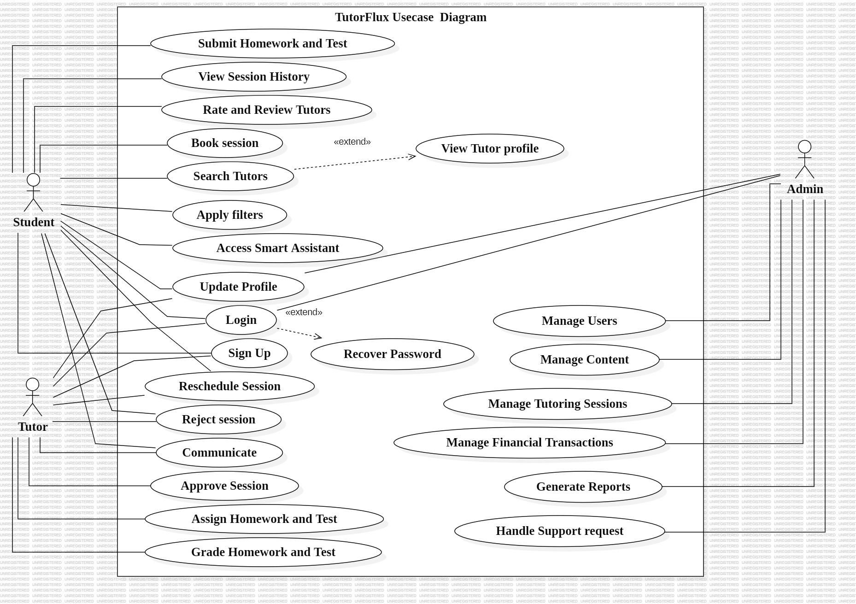

Figure 24 : TutorFlux Use case Diagram

## Class Diagram

A class diagram is a UML diagram representing the static structure of a system or software application using classes, interfaces, associations, and other elements. It visualizes the architecture of the system, showing classes, their attributes, methods, and relationships between them. Class diagrams facilitate understanding, communication, and the design and implementation of software systems. The class diagram for TutorFlux represents the static structure of the system, showing classes, their attributes, methods, and relationships.

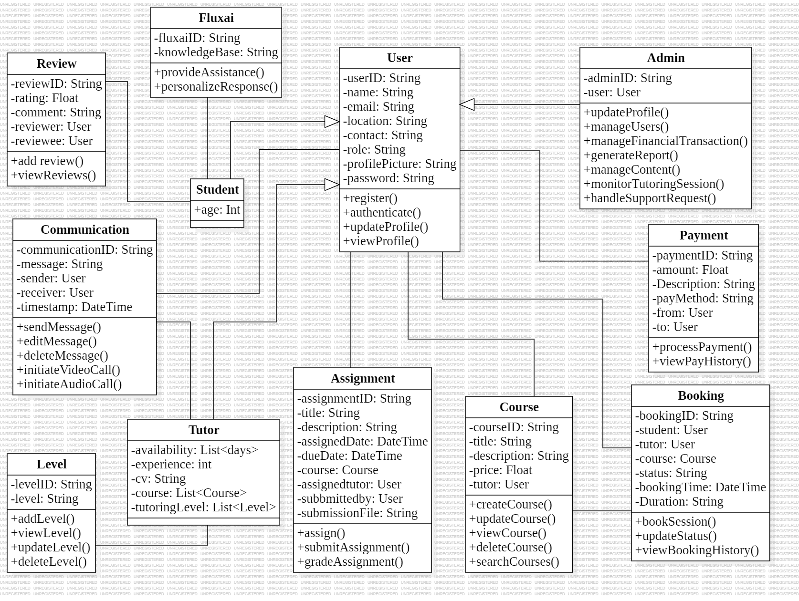

Figure 25 : Class Diagram

## Sequence Diagram

A sequence diagram is an interaction diagram that shows how processes operate with one another and in what order. It visualizes the sequence of messages exchanged between objects in a system, capturing the dynamic behaviour. Sequence diagrams detail the flow of control and data among objects, helping understand and document functional requirements and system architecture. The sequence diagram for TutorFlux shows the flow of interactions between the student, tutor, and system for booking a tutoring session.

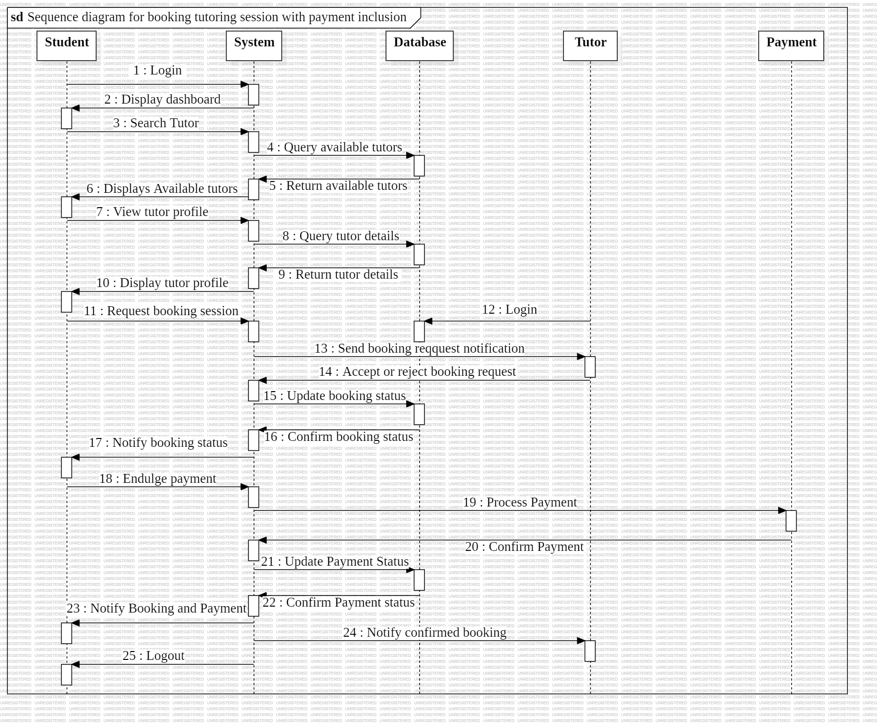

Figure 26 : Sequence Diagram for booking Tutoring Session with payment inclusion

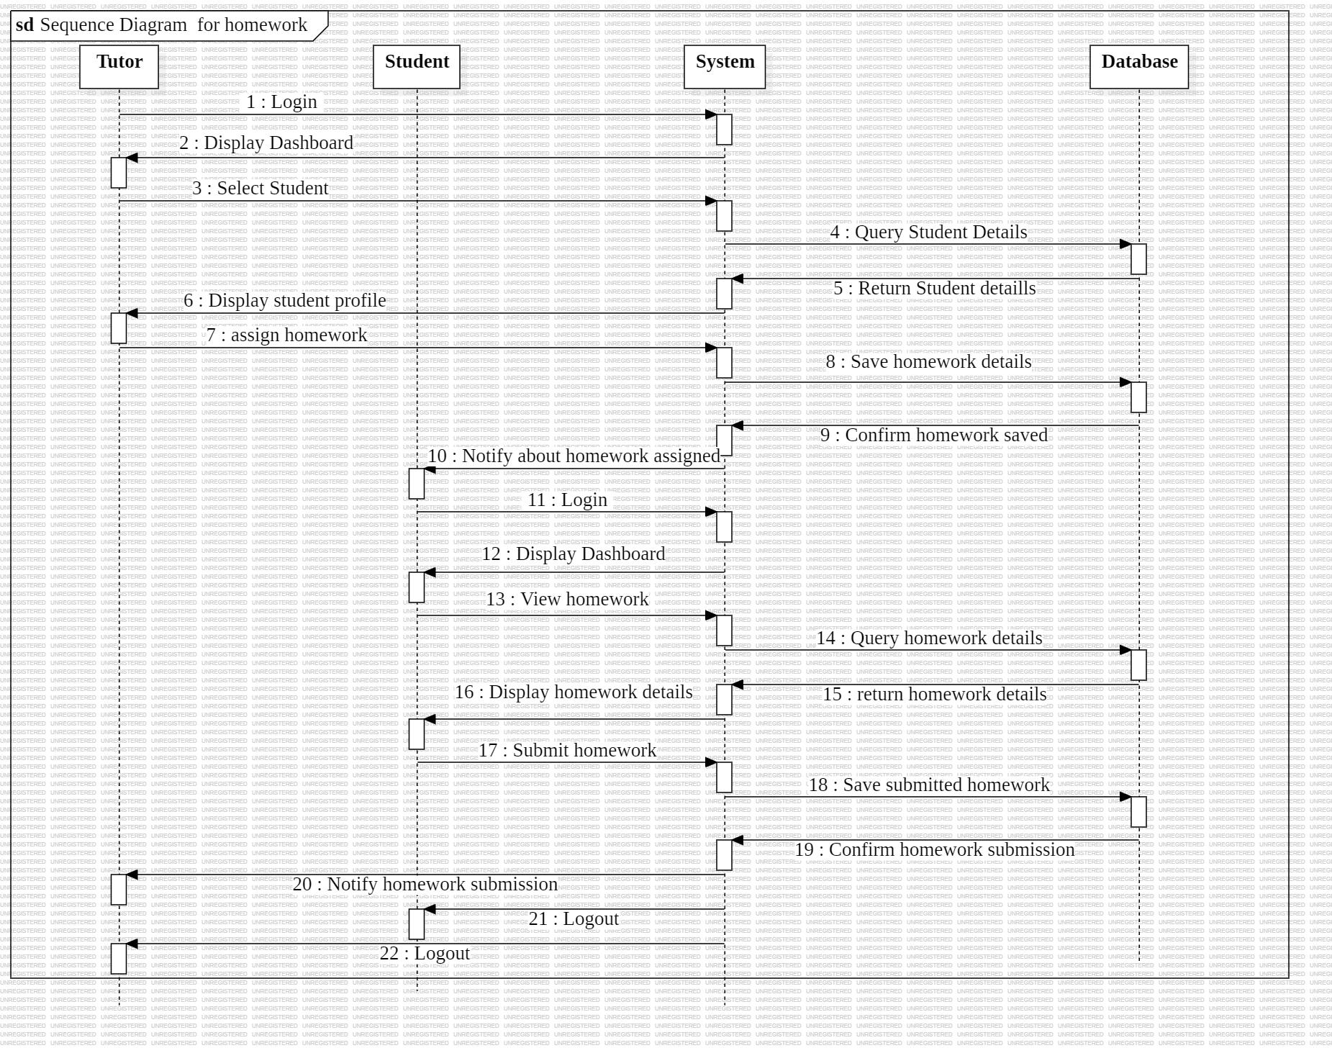

Figure 27 : Sequence Diagram for Homework

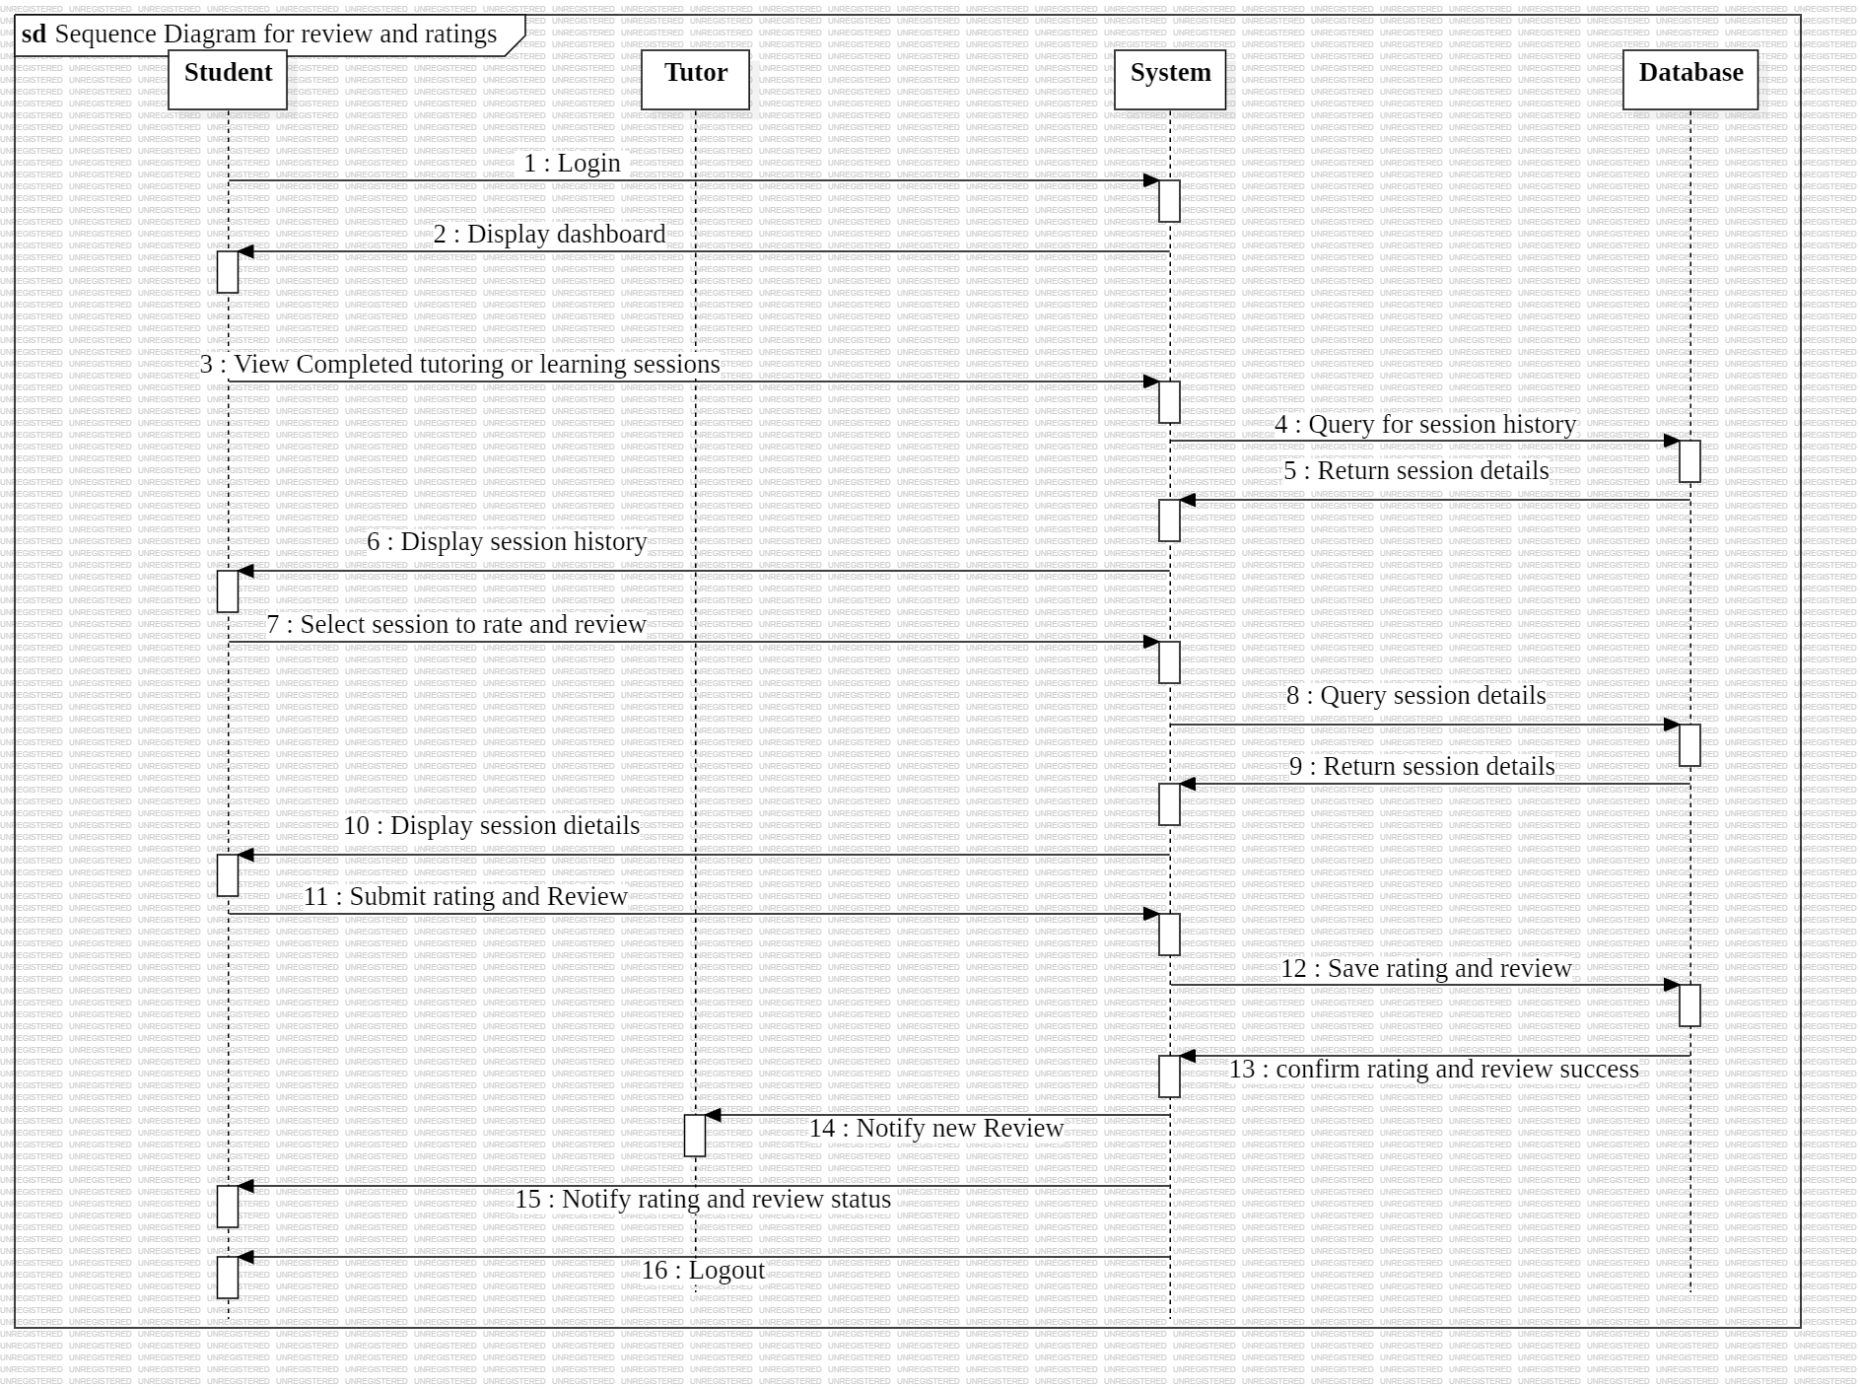

Figure 28 : Sequence Diagram for Tutor Review and Rating

# IMPLEMENTATION

The implementation phase involves translating the design specifications into actual code using the tools and technologies listed in the methodology. It includes developing the front-end and back-end components, integrating the various modules, and ensuring the system functions as intended. This phase also encompasses unit testing to verify that individual components work correctly before moving on to integration and system testing.

This design chapter ensures that TutorFlux is developed using a systematic approach, employing various UML diagrams to capture both static and dynamic aspects of the system. Each diagram serves a specific purpose, aiding in the clear communication of system architecture and facilitating a smooth transition from design to implementation.

# References

*2021_Annual_Report*. (n.d.).

Al-Maroof, R. S., Alnazzawi, N., Akour, I. A., Ayoubi, K., Alhumaid, K., Alahbabi, N. M., Alnnaimi, M., Thabit, S., Alfaisal, R., Aburayya, A., & Salloum, S. (2021). The effectiveness of online platforms after the pandemic: Will face-to-face classes affect students’ perception of their behavioural intention (BIU) to use online platforms? *Informatics*, *8*(4). https://doi.org/10.3390/informatics8040083

Al-Rahmi, A. M., Shamsuddin, A., Alturki, U., Aldraiweesh, A., Yusof, F. M., Al-Rahmi, W. M., & Aljeraiwi, A. A. (2021). The influence of information system success and technology acceptance model on social media factors in education. *Sustainability (Switzerland)*, *13*(14). https://doi.org/10.3390/su13147770

Baer, H., Chatterjee, D., Colgan, M., Fries, M., Gongloor, P., Jernigan, K., Lee, S. K., Lee, W., Mcdermid, D., Shaft, U., Suro, O., Tran, T., Vrinda, S., & Wang, Y. (2021). *Oracle® Database Database Performance Tuning Guide 21c Oracle Database Database Performance Tuning Guide, 21c*.

BLOOM, B. S. (1984). The 2 Sigma Problem: The Search for Methods of Group Instruction as Effective as One-to-One Tutoring. *Educational Researcher*, *13*(6), 4–16. https://doi.org/10.3102/0013189X013006004

Bray, M., Unesco., & International Institute for Educational Planning. (2009). *Confronting the shadow education system : what government policies for what private tutoring?* United Nations Educational, Scientific and Cultural Organization.

Carlana, M., & Ferrara, E. La. (2021). *Apart but Connected: Online Tutoring and Student Outcomes during the COVID-19 Pandemic*. www.iza.org

Chen, P.-S. D., Lambert, A. D., & Guidry, K. R. (2010). Engaging online learners: The impact of Web-based learning technology on college student engagement. *Computers & Education*, *54*(4), 1222–1232. https://doi.org/https://doi.org/10.1016/j.compedu.2009.11.008

Cheung, A. C. K., & Slavin, R. E. (2013). The effectiveness of educational technology applications for enhancing mathematics achievement in K-12 classrooms: A meta-analysis. *Educational Research Review*, *9*, 88–113. https://doi.org/10.1016/J.EDUREV.2013.01.001

Conwell, N. P., & Stanslaus, V. (2020). THE CONTRIBUTION OF MOBILE MONEY SERVICES ON SMES INTERNATIONALIZATION IN TANZANIA: A CASE OF EPZA. *International Journal of Business Management and Economic Review*, *03*(02), 61–83. https://doi.org/10.35409/ijbmer.2020.3168

Cutler, D. M., & Lleras-Muney, A. (2006). *NBER WORKING PAPER SERIES EDUCATION AND HEALTH: EVALUATING THEORIES AND EVIDENCE Education and Health: Evaluating Theories and Evidence*. http://www.dh.gov.uk/PolicyAndGuidance/HealthAndSocialCareTopics/HealthInequalities/fs/en

Danilo, O., Alvarez, G., Puente Riofrío, M. I., Tahirí, N., Cabezas, M., Maritza, I., Ñauñay, V., Joel, E., Vela, C., Ariel, K., Cardenas, C., & Angel, L. (2023). Comparative Analysis of Cross-Platform Frameworks. *Journal of Namibian Studies*, 33–35.

Dayang, P., & Hamza, A. (2021). Using USSD-based Mobile Payment in Context of Low Internet Connection. *International Journal of Wireless Communications and Mobile Computing*, *9*(1), 1. https://doi.org/10.11648/j.wcmc.20210901.11

de Castro, B. V, & de Guzman, A. B. (2014). From Scratch to Notch: Understanding Private Tutoring Metamorphosis in the Philippines From the Perspectives of Cram School and Formal School Administrators. *Education and Urban Society*, *46*(3), 287–311. https://doi.org/10.1177/0013124512439888

Doyle, M., Williams, L., Cohn, M., & Rubin, K. S. (2014). Agile Software Development in Practice. In *LNBIP* (Vol. 179). http://ambysoft.com/

Falk, K. B., & Wehby, J. H. (2001). The Effects of Peer-Assisted Learning Strategies on the Beginning Reading Skills of Young Children with Emotional or Behavioral Disorders. *Behavioral Disorders*, *26*(4), 344–359. https://doi.org/10.1177/019874290102600404

Fraenkel, J., Wallen, N., & Hyun, H. (1993). *How to Design and Evaluate Research in Education 10th ed.* McGraw-Hill Education.

Grassini, S. (2023). Shaping the Future of Education: Exploring the Potential and Consequences of AI and ChatGPT in Educational Settings. In *Education Sciences* (Vol. 13, Issue 7). Multidisciplinary Digital Publishing Institute (MDPI). https://doi.org/10.3390/educsci13070692

Griffin, M. M., & Griffin, B. W. (1998). An Investigation of the Effects of Reciprocal Peer Tutoring on Achievement, Self-Efficacy, and Test Anxiety. *Contemporary Educational Psychology*, *23*(3), 298–311. https://doi.org/https://doi.org/10.1006/ceps.1998.0971

Gst, I., & Triyoga, A. (2019). Design of Cloud Computing-based Geographic Information Systems for Mapping Tutoring Agencies. In *International Journal of Computer Applications Technology and Research* (Vol. 8, Issue 10). www.ijcat.com

Guerra-Martín, M. D., Lima-Serrano, M., & Lima-Rodríguez, J. S. (2017). Effectiveness of tutoring to improve academic performance in nursing students at the University of Seville. *Journal of New Approaches in Educational Research*, *6*(2), 93–102. https://doi.org/10.7821/naer.2017.7.201

Hamdan, J. S., Lehmann-Uschner, K., & Menkhoff, L. (2022). Mobile Money, Financial Inclusion, and Unmet Opportunities: Evidence from Uganda. *Journal of Development Studies*, *58*(4), 671–691. https://doi.org/10.1080/00220388.2021.1988078

Haque, S., Eberhart, Z., Bansal, A., & McMillan, C. (2022). Semantic Similarity Metrics for Evaluating Source Code Summarization. *IEEE International Conference on Program Comprehension*, *2022-March*, 36–47. https://doi.org/10.1145/nnnnnnn.nnnnnnn

Harasim, L. (2000). Shift happens: online education as a new paradigm in learning. *The Internet and Higher Education*, *3*(1), 41–61. https://doi.org/https://doi.org/10.1016/S1096-7516(00)00032-4

Hawalah, A., & Fasli, M. (n.d.). *Dynamic User Profiles for Web Personalization*. http://www.dmoz.org/

Herinek, D., Woodward-Kron, R., Huber, M., Helmer, S. M., Körner, M., & Ewers, M. (2022). Interprofessional peer-assisted learning and tutor training practices in health professions education–A snapshot of Germany. *PLoS ONE*, *17*(12 December). https://doi.org/10.1371/journal.pone.0278872

Herrera Bohórquez, L. I., Largo Rodríguez, J. D., & Viáfara González, J. J. (2019). Online peer-tutoring: a renewed impetus for autonomous English learning. *HOW*, *26*(2), 12–31. https://doi.org/10.19183/how.26.2.503

Hill, J. R., & Hannafin, M. J. (2001). Teaching and Learning in Digital Environments: The Resurgence of Resource-Based Learning. In *ETR&D* (Vol. 49, Issue 3).

Hockly, N., & Dudeney, G. (2018). Current and Future Digital Trends in ELT. *RELC Journal*, *49*(2), 164–178. https://doi.org/10.1177/0033688218777318

Ireson, J. (2007). Private Tutoring: how prevalent and effective is it? *London Review of Education*, *2*(2). https://doi.org/10.1080/1474846042000229458

Josta Lameck Nzilano, B. (2015). *Influences and Outcomes of Social Constructivist Curriculum Implementation on Tutors’ Beliefs and Practices in Teacher Education Colleges in Tanzania*.

Kim, E. J., Kim, J. J., & Han, S. H. (2021). Understanding student acceptance of online learning systems in higher education: Application of social psychology theories with consideration of user innovativeness. *Sustainability (Switzerland)*, *13*(2), 1–14. https://doi.org/10.3390/su13020896

Kulik, J. A., Kulik, C.-L. C., & Cohen, P. A. (1980). Effectiveness of Computer-based College Teaching: A Meta-analysis of Findings. *Review of Educational Research*, *50*(4), 525–544. https://doi.org/10.3102/00346543050004525

Kumar, G., Kumar Bhatia, P., & Jambheshwar, G. (2012). Impact of Agile Methodology on Software Development Process. In *International Journal of Computer Technology and Electronics Engineering (IJCTEE* (Vol. 2, Issue 4). https://www.researchgate.net/publication/255707851

Malik, J., & Pastore, F. (2023). An empirical study of vulnerabilities in edge frameworks to support security testing improvement. *Empirical Software Engineering*, *28*(4). https://doi.org/10.1007/s10664-023-10330-x

Mandadi, R. K. (n.d.). *Comparison of Current On-line Payment Technologies Master thesis performed in division of Information Theory*.

Manubey, J., Batlolona, J. R., & Leasa, M. (2021). Peer tutoring analysis in inclusive classes using character education approach. *Journal of Education and Learning (EduLearn)*, *15*(2), 303–311. https://doi.org/10.11591/edulearn.v15i2.19190

Mejeh, M., & Rehm, M. (2024). Taking adaptive learning in educational settings to the next level: leveraging natural language processing for improved personalization. *Educational Technology Research and Development*. https://doi.org/10.1007/s11423-024-10345-1

Merriam, S. B., & Tisdell, E. J. (n.d.). *Qualitative research : a guide to design and implementation*.

Pau, K. N., Lee, V. W. Q., Ooi, S. Y., & Pang, Y. H. (2023). The Development of a Data Collection and Browser Fingerprinting System. *Sensors*, *23*(6). https://doi.org/10.3390/s23063087

Pham, L., Limbu, Y. B., Bui, T. K., Nguyen, H. T., & Pham, H. T. (2019). Does e-learning service quality influence e-learning student satisfaction and loyalty? Evidence from Vietnam. *International Journal of Educational Technology in Higher Education*, *16*(1). https://doi.org/10.1186/s41239-019-0136-3

Pina, E., Sá, F., & Bernardino, J. (2023). NewSQL Databases Assessment: CockroachDB, MariaDB Xpand, and VoltDB. *Future Internet*, *15*(1). https://doi.org/10.3390/fi15010010

Raj Srivastava AssttGeneral Manager, D., & Raj Srivastava, D. (2015). *The role of mobile money and digital financial services*. *3*(1). http://orcid.org/0000-0003-3189-2235

Rienovita, E., Taniguchi, M., Kawahara, M., Hayashi, Y., & Takeuchi, Y. (n.d.). *Implementation of Interactive Peer Learning Environment Enhances Learners" Self-Esteem and Self-Efficacy*.

Sawant, S. (2023). A Study on the Digital Payment Gateways and its Future. *INTERANTIONAL JOURNAL OF SCIENTIFIC RESEARCH IN ENGINEERING AND MANAGEMENT*, *07*(04). https://doi.org/10.55041/ijsrem18908

Schoone, A. (2021). Can Concrete Poems Fly? Setting Data Free in a Performance of Visual Enactment. *Qualitative Inquiry*, *27*(1), 129–135. https://doi.org/10.1177/1077800419884976

Schumacher, K. (2022). *Benchmarking NewSQL Database VoltDB* [San Jose State University]. https://doi.org/10.31979/etd.9z8m-fjqn

Shen, X., & Liu, J. (2022). Analysis of Factors Affecting User Willingness to Use Virtual Online Education Platforms. *International Journal of Emerging Technologies in Learning*, *17*(1), 74–89. https://doi.org/10.3991/ijet.v17i01.28713

Sili, M., Garschall, M., Morandell, M., Hanke, S., & Mayer, C. (2016). Personalization in the user interaction design: Isn’t personalization just the adjustment according to defined user preferences? *Lecture Notes in Computer Science (Including Subseries Lecture Notes in Artificial Intelligence and Lecture Notes in Bioinformatics)*, *9731*, 198–207. https://doi.org/10.1007/978-3-319-39510-4_19

Svellingen, A., Røssland, A., & Røykenes, K. (2021). Students as Facilitators: Experiences of Reciprocal Peer Tutoring in Simulation-Based Learning. *Clinical Simulation in Nursing*, *54*, 10–16. https://doi.org/10.1016/j.ecns.2021.01.008

Tan, S. (2023). Harnessing Artificial Intelligence for Innovation in Education. In *Learning Intelligence: Innovative and Digital Transformative Learning Strategies: Cultural and Social Engineering Perspectives* (pp. 335–363). Springer Nature Singapore. https://doi.org/10.1007/978-981-19-9201-8_8

Thakur, B. K., Abbas, S. Q., & Beg, Mohd. R. (2014). Web Personalization Using Clustering of Web Usage Data. *International Journal in Foundations of Computer Science & Technology*, *4*(5), 69–84. https://doi.org/10.5121/ijfcst.2014.4507

*The State of the Industry Report on Mobile Money*. (2024). www.gsma.com/mobilemoney

VanLEHN, K. (2011). The Relative Effectiveness of Human Tutoring, Intelligent Tutoring Systems, and Other Tutoring Systems. *Educational Psychologist*, *46*(4), 197–221. https://doi.org/10.1080/00461520.2011.611369

Venkat, S., K, N., Vishal, P., Yaseen, S., & Rana, P. (2022). A Reviewed Analysis of the Technological Trends in E-Commerce. *International Journal for Research in Applied Science and Engineering Technology*, *10*(4), 2660–2666. https://doi.org/10.22214/ijraset.2022.41825

Vinícius de Souza Toledo, M., Dutra de Carvalho Lemos, K., de Souza Toledo, B., & Cláudio Gomes Maia, L. (2019). *Virtual Tutor as an Assistant Technology Tool in Learning English in a School*.

Wenting Ma Simon, Olusola O. Adesope, John C. Nesbit, & Qing Liu. (2014). Supplemental Material for Intelligent Tutoring Systems and Learning Outcomes: A Meta-Analysis. *Journal of Educational Psychology*. https://doi.org/10.1037/a0037123.supp

Xu, Z., Zhuang, L., He, M., Yang, S., Song, Y., Guo, J., & Li, W. (2023). An edge-based approach for virtual network embedding based on the graph edit distance. *PLoS ONE*, *18*(7 JULY). https://doi.org/10.1371/journal.pone.0288037

Yu, C. H. (2009). Book Review: Creswell, J., & Plano Clark, V. (2007). Designing and Conducting Mixed Methods Research. Thousand Oaks, CA: Sage. *Organizational Research Methods*, *12*(4), 801–804. https://doi.org/10.1177/1094428108318066

Zhao, H., & Khan, A. (2022). The Students’ Flow Experience With the Continuous Intention of Using Online English Platforms. *Frontiers in Psychology*, *12*. https://doi.org/10.3389/fpsyg.2021.807084

Zhao, Y., Bandyopadhyay, K., & Bandyopadhyay, S. (n.d.). *What Matters Most in Online SAP-Enabled Course Learning? A System View of Determinants*. https://hdl.handle.net/10125/60196